Roll No. : 20MCMB15-IT Name : Sachin Y. Sah

Assignment – 1

Q.1)

index.html

<!DOCTYPE html> <!-- declaration is not an HTML tag. It is just an information for the browser about what is the document type -->
<html> <!-- This tag is the root of the html document and acts as container for all other html elements-->
<head> <!-- This tag is a container for metadata (data about data) and is placed between the <html> tag and the <body> tag. Metadata basically define the document title, character set, styles, scripts, and other meta information -->

<!-- external css file is linked with this html file -->
<link rel="stylesheet" type="text/css" href="index.css">

<!-- This <title> tag defines the title of the document. it is shown in the browser's title bar or in the page's tab -->
<title>
Types of List | 20MCMB15
</title>
</head>
<body bgcolor="#4f55d2">

<!-- The <iframe> tag specifies an inline frame and is used to embed another document within the current HTML document. -->
<iframe src="list.html" name="first_frame" height="100%" width="25%" align="left" frameborder="1"></iframe>
<iframe src="dash.html" name= "second_frame" height="100%" width="74%" align="right" frameborder="1"></iframe>
</body>
</html>

list.html

<!DOCTYPE html>
<html>
<head>
<title></title>
</head>
<body bgcolor="#4f55d2">

Types of List :<br><br>
<!-- target attribute of anchor tag is used to select space.frame to display the file kept in href -->
1. <a href="ul.html" target="second_frame">Bulleted List</a><br><br>

2. <a href="ol.html" target="second_frame">Numbered List</a><br><br>

3. <a href="dl.html" target="second_frame">Definition List</a><br><br>

</body>
</html>

ol.html

<!DOCTYPE html>
<html>
<body>

<br>
<ul>
<li>The HTML ol tag is used for ordered list.</li>
<li>We can use ordered list to represent items either in numerical order format or alphabetical order format, or any format where an order is emphasized.</li>
</ul>
<br>
<ul>
<li>There can be different types of numbered list:</li>
</ul>

<!-- <ol> ordered list items will usually be displayed with numbers or letters and <li> tag defines a list item -->
<ol>
<li>Numeric Number (1, 2, 3)</li>
<li>Capital Roman Number (I II III)</li>
<li>Small Romal Number (i ii iii)</li>
<li>Capital Alphabet (A B C)</li>
<li>Small Alphabet (a b c)</li>
</ol>

Capital Roman Number (I II III)
<ol type="I">
<li>Java</li>
<li>Android</li>
<li>Firebase</li>
</ol>

Small Romal Number (i ii iii) starting with 4
<ol type="i" start="4">
<li>Java</li>
<li>Android</li>
<li>Firebase</li>
</ol>

Capital Roman Number (I II III) in descending order
<ol type="I" reversed>
<li>Java</li>
<li>Android</li>
<li>Firebase</li>
</ol>

Capital Alphabet (A B C)
<ol type="A">
<li>Java</li>
<li>Android</li>
<li>Firebase</li>
</ol>

Small Alphabet (a b c)
<ol type="a">
<li>Java</li>
<li>Android</li>
<li>Firebase</li>
</ol>

</body>
</html>

ul.html

<!DOCTYPE html>
<html>
<body >

<br>
<!-- The <ul> tag defines an unordered (bulleted) list and and <li> tag defines a list item -->
<ul>
<li>HTML Unordered List or Bulleted List displays elements in bulleted format.</li>
<li>We can use unordered list where we do not need to display items in any particular order.</li>
<li>The HTML ul tag is used for the unordered list.</li>
</ul>

There can be 4 types of bulleted list:
<ul>
<li>disc</li>
<li>circle</li>
<li>square</li>
<li>none</li>
</ul>

circle
<ul type="circle">
<li>Java</li>
<li>Android</li>
<li>Firebase</li>
</ul>

square
<ul type="square">
<li>Java</li>
<li>Android</li>
<li>Firebase</li>
</ul>

disc
<ul type="disc">
<li>Java</li>
<li>Android</li>
<li>Firebase</li>
</ul>

none
<ul type="none">
<li>Java</li>
<li>Android</li>
<li>Firebase</li>
</ul>

</body>
</html>

dl.html

<!DOCTYPE html>
<html>
<body>

<!-- This <dl> tag defines a description list and it is used in conjunction with <dt> (defines topic) and <dd> (describes each topic)-->

<br>
<ul>
<li>The HTML dl tag is used for declaring a definition list.</li>
<li>This tag is used within dd tag.</li>
<li>A definition list is similar to other lists but in a definition list, each list item contains two entries; a term and a description.</li>
</ul>

<dl>
<dt>Java</dt>
<dd>Java is a class-based, object-oriented programming language that is designed to have as few implementation dependencies as possible.</dd><br>
<dt>Android</dt>
<dd>Android is a mobile operating system based on a modified version of the Linux kernel and other open source software, designed primarily for touchscreen mobile devices such as smartphones and tablets.</dd><br>

<dt>Firebase</dd>
<dd>Firebase is a platform developed by Google for creating mobile and web applications.</dd>
</dl>

</body>
</html>

dash.html

<!DOCTYPE html>
<html>
<head>

<link rel="stylesheet" type="text/css" href="index.css">
<title></title>
</head>
<body>

<!-- <h> tag is used for heading. it ranges from h1 to h6 -->
<h4 class="center">Click on the option given on the left side to explore the term</h4>

</body>
</html>

index.css

html,body{
width: 100%;
height: 100%;
}

.center{
position:absolute;
left:30%;
top:30%;
}

OUTPUT :

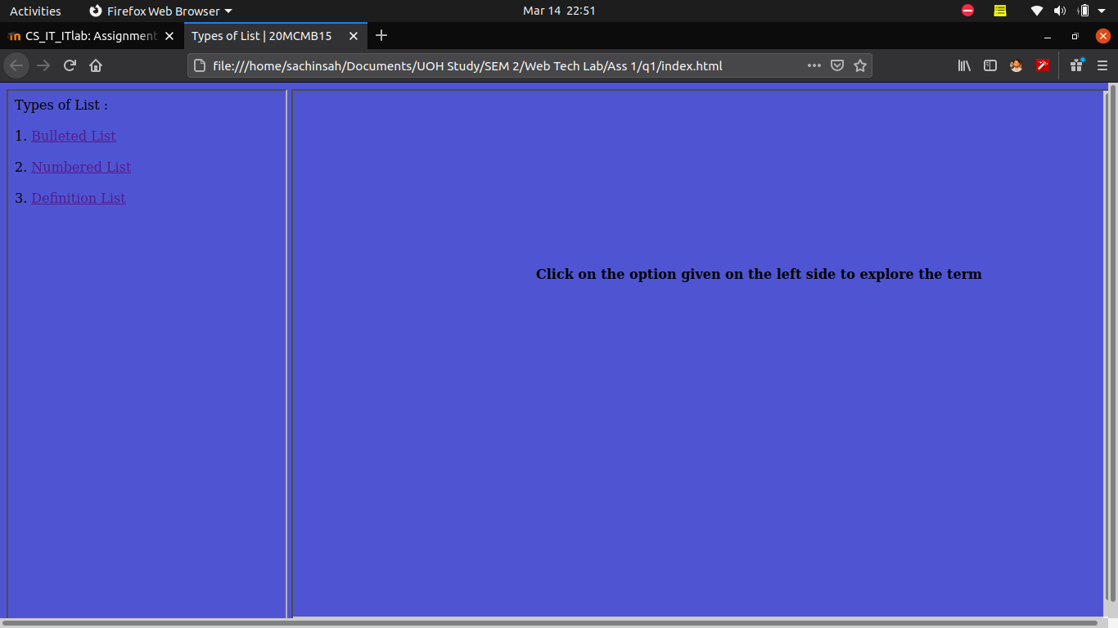

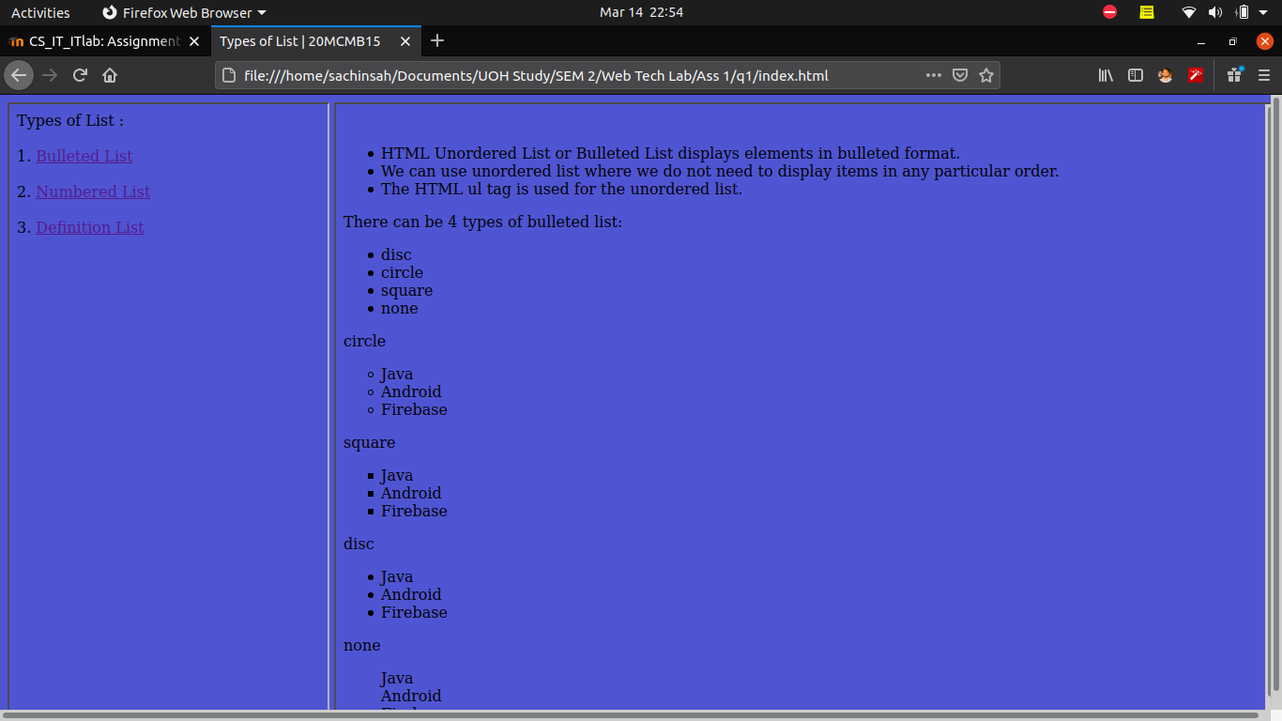

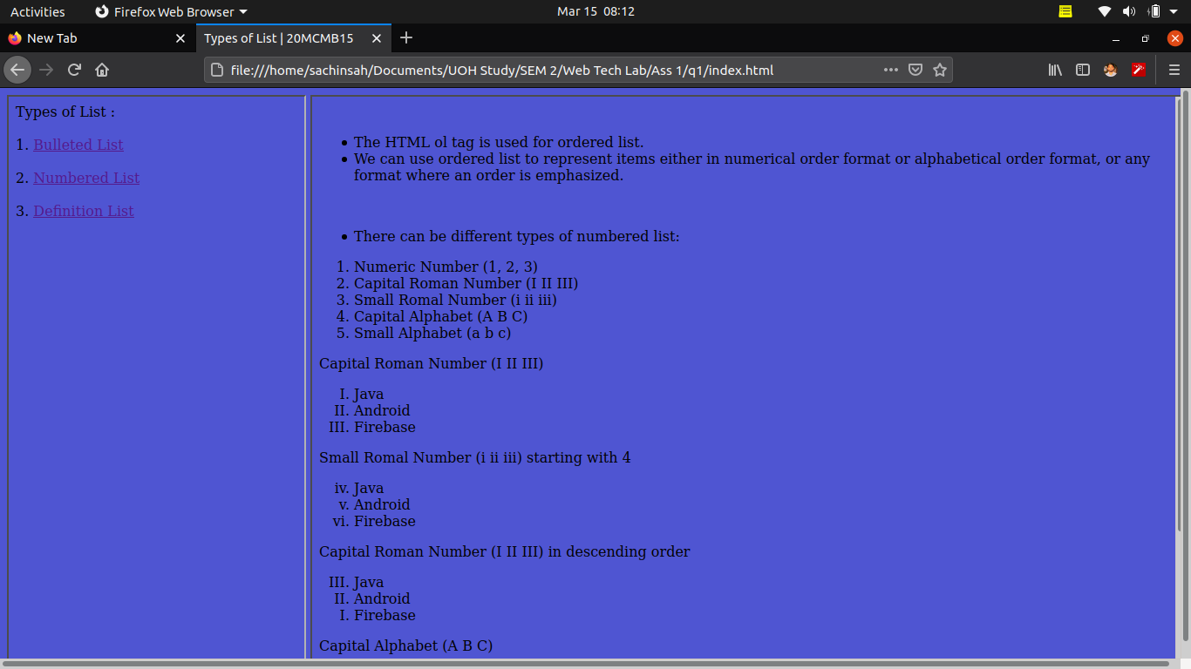

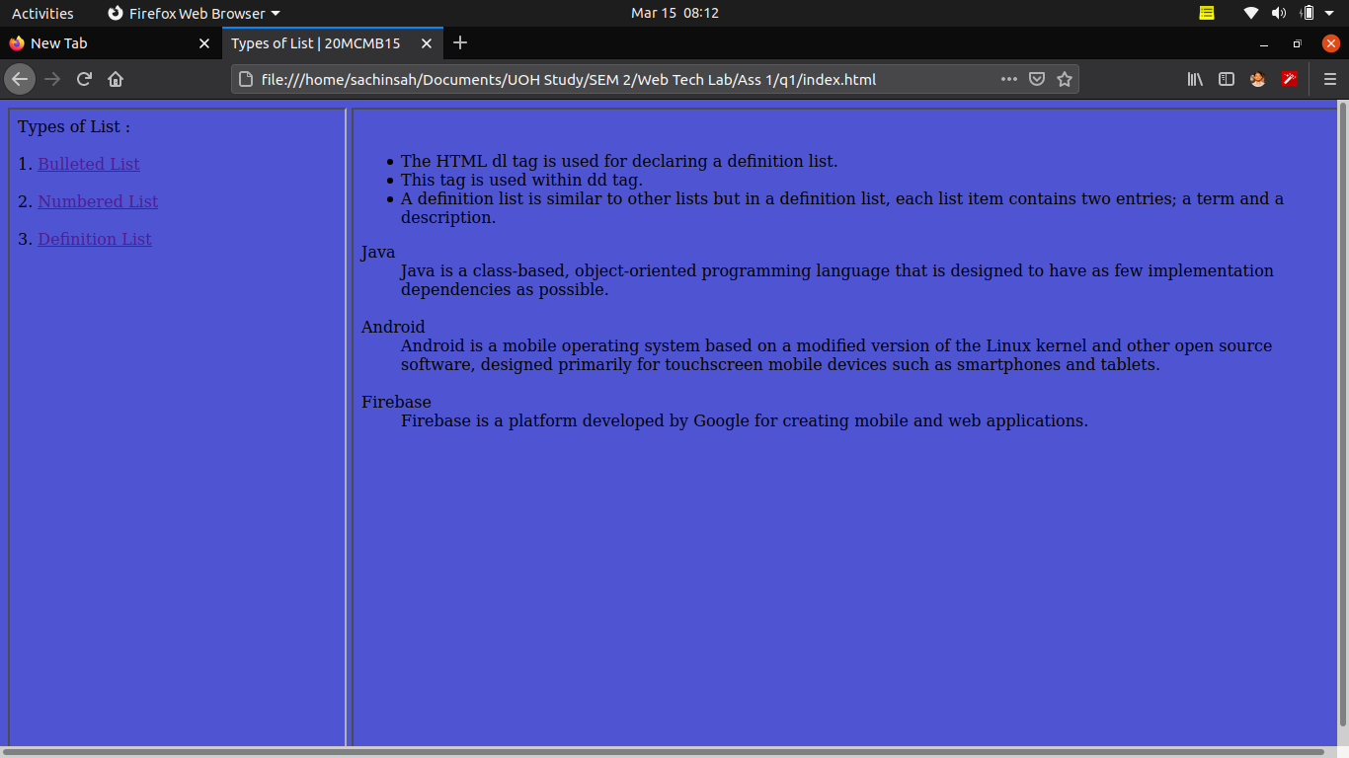

Q.2)

timetable.html

<!DOCTYPE html>
<html>
<head>
<title>Time Table | 20MCMB15</title>
</head>
<body bgcolor="#4f55d2">
<h1><font><center>MTECH-IT TIME TABLE</font></h1>
<table border="3" cellspacing="5" align="center"><!-- Table tag is sued tocreate table. cellspacing attribute is used for have space between fields. align attribute is used for set table in center-->
<tr> <!-- tr for table row -->
<td align="center">Day <!-- td for table column -->
<td>9:00-10:00
<td>10:00-11:00
<td>11:00-12:00
<td>12:00-01:00
<td>01:00-02:00
<td>02:00-03:00
<td>03:00-04:00
<td>04:00-05:00
</tr>
<tr>
<td align="center">MONDAY
<td colspan="2" align="center">System Security <!-- colspan attribute for setting column size here i have used colspan=2 means column size is of 2 column field size -->
<td align="center"><font color="pink">Software Engineering<br> <!-- font tag is used to set style of the the text. here color attribute is used to set color of the text. -->
<td align="center"><font color="red"><br>
<td rowspan="6"align="center">B<br>R<br>E<br>A<br>K <!-- rowspan attribute for setting row size here i have used rowspan=2 means row size is of 2 row field size -->
<td colspan="2" align="center"><font color="maroon">Comm. Skills<br>
<td align="center"><font color="brown"><br>
</tr>
<tr>
<td align="center">TUESDAY
<td colspan="2" align="center">Data Compression
<td align="center"><font color="pink">Network Security<br>
<td align="center"><font color="red">IOT<br>
<td colspan="3" align="center"><font color="maroon"> Web Technologies Lab
</tr>

<tr>
<td align="center">WEDNESDAY
<td colspan="4" align="center"><font color="pink">Not Decided<br>
<td colspan="3" align="center"><font color="maroon"> Software Engineering Lab
</tr>

<tr>
<td align="center">THURSDAY
<td colspan="2" align="center">Network Security
<td align="center"><font color="pink">System Security<br>
<td align="center"><font color="red">Software Engineering<br>
<td colspan="2" align="center"><font color="maroon">Communication Lab
</tr>

<tr>
<td align="center">FRIDAY
<td colspan="2" align="center">IOT
<td align="center"><font color="pink">Data Compression<br>
<td align="center"><font color="red">Not Decided<br>
<td colspan="2" align="center"><font color="maroon"> Not Decided
</tr>

</body>
</html>

Output :

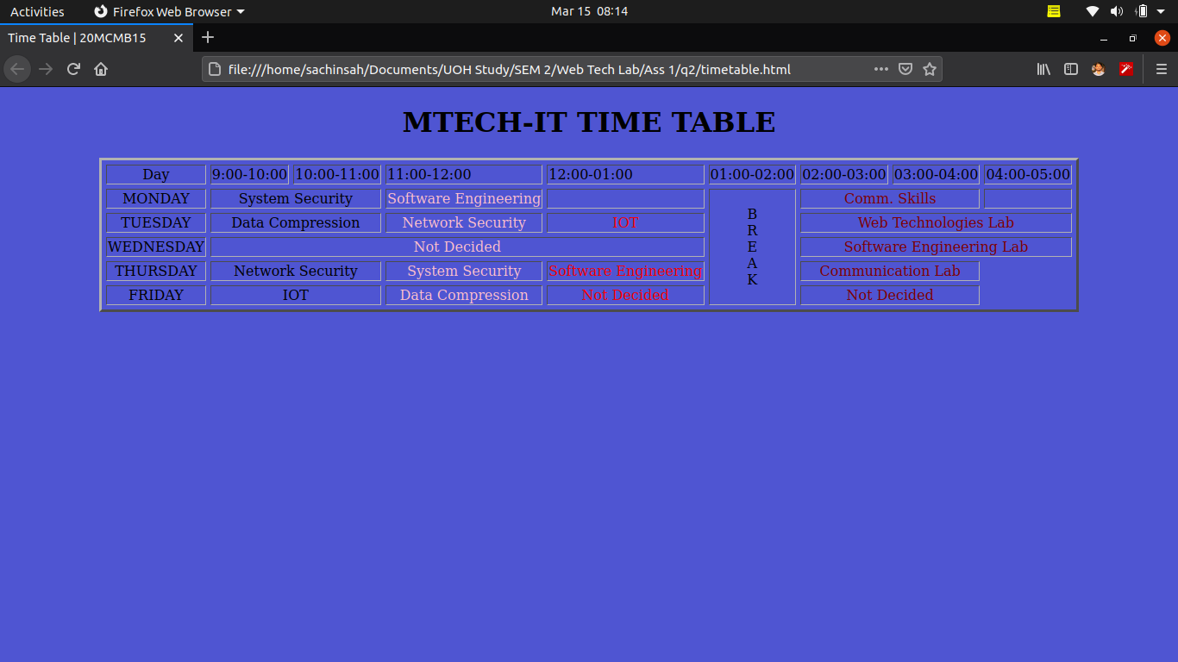

Q.3)

countries.html

<!DOCTYPE html>
<html>
<head>
<title>List of Countries | 20MCMB15</title>

</head>
<body bgcolor="#4f55d2">

<center><!-- keep thing in the center of the screen -->
<h2>Select Countries</h2>
<select name="country" multiple="multiple"> <!-- This <select> tag is used to create a drop-down list and mutiple attribute to enable the multiple selection -->
<!-- option tag with add element in the drop-down list-->
<option value="india">INDIA</option> <br><br> <!-- value attribute is used for getting the value when corresponding option is selected -->
<option value="afganisthan" selected="true">AFGANISTHAN</option> <br><br><!-- selection attribute set true will select the option by default -->
<option value="usa">USA</option> <br><br>
<option value="dubai">DUBAI</option> <br><br>
<option value="uae">UAE</option> <br><br>
<option value="southafrica" selected="true">SOUTH AFRICA</option> <br><br>
<option value="newzealand">NEW ZEALAND</option> <br><br>
<option value="france">FRANCE</option> <br><br>
<option value="australia">AUSTRALIA</option> <br><br>
<option value="europe" selected="true">EUROPE</option> <br><br>
<option value="england">ENGLAND</option> <br><br>
</select>
</center>

</body>
</html>

Output :

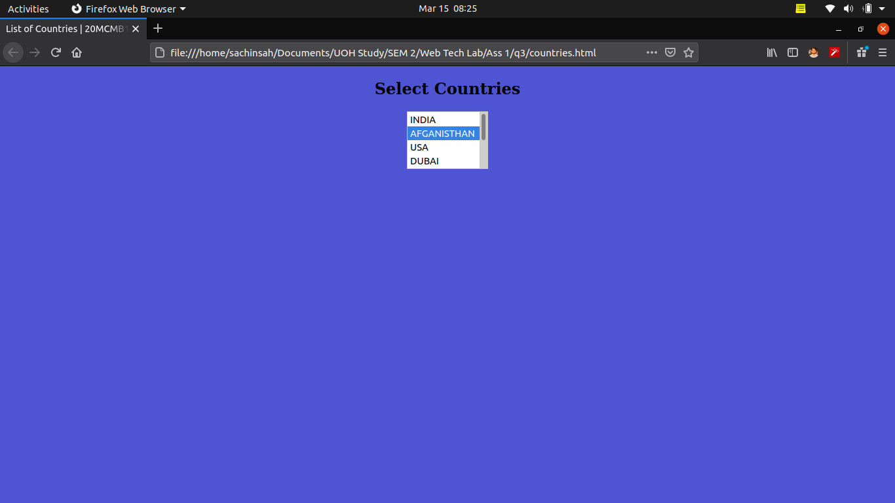

Q.4)

product.html

<!DOCTYPE html>
<html>
<head>

<title>List of Product|20MCMB15</title>

<!-- Setting each section height to 100vh so that is other section don't show up because content is small in each section so to avoid other section to show up in other while clicking on the click-->
<style type="text/css">
section{
height: 100vh;
}

</style>
</head>
<body bgcolor="#4f55ff">

<br>
<br>
<section><!-- This <section> tag defines a section in a document. -->
<center>
<H1> List of Products : </H1><br><br>
<ol>
<li><a href="#royalbulletclassic350"><h3> Royal Enfield Classic 350 </h3></a><br><br>
<!-- #sectionid is used for internal link within section -->
<li><a href="#ktm125"><h3> KTM 125 Duke </h3></a><br><br>
<li><a href="#royalbullet350"><h3> Royal Enfield Bullet 350 </h3></a><br><br>
</ol>
</center>
</section>

<section id="royalbullet350"> <!-- The id attribute is used for provide id to section which can be used to track the section in the document-->

<center><H1>Royal Enfield Bullet 350</H1></center>
<p>Royal Enfield has hiked the prices of the Bullet 350 and the Bullet 350 ES for the second time this year. This time around, the premium is around Rs 3,200 to Rs 3,500. Here’s the full price list.When the Royal Enfield Bullet 350 BS6 was launched, it commanded a premium of Rs 5,910 over the previous-gen BS4 model. But with subsequent hikes over the months, the price gap has widened even further.The Royal Enfield Bullet 350 is the oldest motorcycle in continuous production. Over the years, it has stayed more or less the same, with only minor modifications to help it comply with our ever-evolving safety and emission norms.<br><br>

Royal Enfield Bullet 350 Price<br><br>
The Royal Enfield Bullet 350 is priced from Rs 1,49,837 for the Bullet Silver and Onyx Black colour versions of the base variant. The Black colour variant with the hand-painted gold pinstripes retails at Rs 1,56,688. The more premium Bullet 350 ES costs Rs 1,67,178 for all three colour options: Jet Black, Regal Red and Royal Blue. All prices are on-road Delhi.<br><br>

Bullet 350 Specifications<br><br>
The Royal Enfield Bullet 350 BS6 uses the same 346cc single-cylinder thumper as the Royal Enfield Classic 350 BS6. The motor produces 19.3PS at 5250rpm and 28Nm at 4000rpm. The gearbox continues to remain a 5-speed unit. The engine nestles inside a traditional single downtube frame linked to a telescopic front fork and twin rear shock absorbers. Braking hardware remains the same as the BS4 version, with a front 280mm disc and 153mm rear drum brake. Royal Enfield had introduced single-channel ABS back in 2019 itself.<br><br>

Royal Enfield Bullet 350 Variants<br>

The Bullet 350 BS6 is offered in two variants: standard and ES. Apart from the electric starter, the ES variant also gets brighter colours on the fuel tank, along with a blacked-out finish on the powertrain and underpinnings. After the recent price hike, the standard variant costs Rs 1,49,837 for the Bullet Silver and Onyx Black colour variants, and Rs 1,56,688 for the Black colour option. On the other hand, all the three colour variants of the Bullet 350 ES (Jet Black, Regal Red and Royal Blue) are priced at Rs 1,67,178. All prices are on-road Delhi.<br><br>

Bullet 350 Design<br>
Over the years, the Royal Enfield Bullet 350’s design has remained more or less the same. Royal Enfield has kept it intact as it evokes the sense of nostalgia associated with basic no-nonsense British motorcycles. The round headlamp with chrome nacelle, the iconic ‘Tiger lamps’, the classic-styled fuel tank, and the single-piece quilted leather seat are all in tune with the bike’s retro look.
Bullet 350 Features<br>

The Royal Enfield Bullet 350 BS6 continues to be a simple, no-frills motorcycle. It doesn’t get any modern features, apart from a fuel injection system and a single-channel ABS. It comes with an analogue instrument cluster, showing only the speedometer and odometer readings, apart from the tell-tale lights. The amp meter pod has been replaced with an engine check light and low fuel light in the BS6 iteration.
Royal Enfield Bullet 350 Competitors<br></p>

</section>

<section id="ktm125">

<center><H1>KTM 125</H1></center>
<p>KTM has revised prices for the 2021 125 Duke. It now costs Rs 1,51,507, which is Rs 1,497 more than before. KTM is offering the same set of updates to the baby Duke as it gave to the 200 Duke earlier this year. That means the same bodywork, split-trellis frame, halogen headlight and LCD instrument console that you find on the 200. It also features a larger 13.5-litre fuel tank, which has played its part in increasing the kerb weight of the bike to 159kg (7kg heavier than before). Here's more details on the new baby Duke. <br><br>

KTM 125 Duke Price<br><br>

KTM 125 Duke price start at Rs. 1.50 Lakh (Ex-Showroom). KTM 125 Duke is offered in only one variant - 2021. <br>

125 Duke Specifications<br><br>

The KTM 125 Duke BS6 employs a BS6-compliant fuel-injected liquid-cooled engine, which generates 14.95PS at 9,250rpm and 12Nm at 8000rpm. Interestingly, there is no drop in power or torque compared to the BS4-compliant version. The engine is mated to a 6-speed transmission. Since it’s a KTM for budget-conscious enthusiasts, the motorcycle lacks a slipper clutch. The KTM 125 Duke BS6 is built on a trellis frame. It continues with the same 43mm WP inverted front fork and WP rear monoshock as the BS4-compliant model. Braking duty is handled by a 300mm front disc with radial caliper and single-channel ABS up front, and a 230mm rear disc.<br><br>

125 Duke Design<br><br>

Design-wise, the KTM 125 Duke BS6 looks pretty similar to the BS6-compliant KTM 200 Duke. It gets the same sharp, mass-forward design language with a halogen headlamp, LED tail light and LED winkers. The sleek tail section is complemented by a meaty tyre and an underbelly exhaust. The exhaust tip is finished in black and even the engine cowl gets a black finish as opposed to orange, white and black graphics in the BS4-compliant version.<br><br>

125 Duke Features<br><br>

The KTM 125 Duke BS6 is loaded with an informative full-LCD instrument cluster. It displays speed, tachometer readings, fuel level, clock, range, distance to empty, and average speed, among other data. The indicators and tail lamp are LED whereas the headlamp is halogen. As far as safety is concerned, it comes with a single-channel ABS.<br><br>

KTM 125 Duke Competitors

The KTM 125 Duke BS6 goes head-to-head against the Yamaha MT-15 BS6.<br><br><br>

</p>
</section>

<section id="royalbulletclassic350" >

<center><H1>Royal Bullet Classsic 350</H1></center>
<p>We recently got our hands on the Classic 350’s waiting period list for March 2021. If you’re looking to buy the old-school thumper, do check out our story first. In other news, Royal Enfield recently hiked the prices of the Classic 350 for the second time in 2021. The single-channel ABS variant now costs Rs 1,67,325 while the dual-channel ABS variant is priced from Rs 1,75,405 to Rs 1,92,608 (ex-showroom Delhi). For full details, check out our dedicated story about the price hike.Royal Enfield is offering a 3-year warranty and 3-year RSA (roadside assistance) as standard on the BS6 Classic 350. The Royal Enfield Classic 350 BS6 rivals the Benelli Imperiale 400 and the Jawa BS6 in the classic motorcycle space.<br><br>

Royal Enfield Classic 350 Price<br><br>
The price of Royal Enfield Classic 350 starts at Rs. 1.67 Lakh and goes upto Rs. 1.92 Lakh. Royal Enfield Classic 350 is offered in 11 variants - STD, Mercury Silver, Pure Black, Classic Black, Gunmetal Grey Spoke, Signals Edition, Orange Ember, Metallo Silver, Gunmetal Grey, Chrome Black and the top variant Classic 350 Stealth Black which comes at a price tag of Rs. 1.92 Lakh.<br><br>

Classic 350 Specifications<br><br>
The Royal Enfield Classic 350 BS6 is powered by a 346cc fuel-injected motor producing 19.3PS at 5250rpm and 28Nm 4000rpm. In comparison, the BS4-compliant 346cc carburetted engine makes 20PS at 5250rpm and 28Nm at 4000rpm. It works alongside a 5-speed transmission. The Royal Enfield Classic 350 BS6 is built on a single downtube frame with the engine as the stressed member. It employs a 35mm telescopic front fork and a pair of gas-charged shock absorbers at the rear. The bike comes with 19-inch front and 18-inch rear spoke or alloy wheels. The spoke wheel variant rides on 90-section front and 110-section rear tubed tyres whereas the alloy wheel variant uses 90-section front and 120-section rear tubeless tyres. Brakes include a 280mm front disc and a 240mm rear disc with dual-channel ABS. Some variants feature single-channel ABS with the rear using a 153mm drum brake instead of a disc.<br><br>

Royal Enfield Classic 350 Variants<br><br>

The Royal Enfield Classic 350 BS6 is available in two variants: Single-channel ABS and Dual-Channel ABS. The single-channel ABS variant is priced at Rs 1,67,235 whereas the dual-channel variant starts from Rs 1,75,405, going all the way up to Rs 1,92,608. All prices are ex-showroom Delhi.
Classic 350 Design <br><br>

Ever since its launch in 2009, the design of the Royal Enfield Classic 350 has remained almost similar. Over the years, Royal Enfield did add new variants like the Redditch Edition, Gunmetal Grey and more recently, the Signals Edition and then the BS6-compliant range. Except for the BS6-compliant iteration, all the other variants featured only cosmetic changes. Despite looking a bit long in the tooth, the Royal Enfield Classic 350 is still the brand’s best-selling motorcycle. This speaks volumes about how customers prefer the design to remain unchanged.<br><br>

Classic 350 Features<br><br>
The Royal Enfield Classic 350 BS6 is a properly old-school motorcycle. It gets a halogen headlamp and bulb indicators as well as tail lamp. The speedometer is a simple analogue unit with just an odometer -- there’s no fuel gauge. However, it comes with a low fuel light and an engine check lamp (in the BS6-compliant version). The more affordable models come with single-channel ABS whereas variants higher up the price range get a dual-channel unit and even alloy wheels in certain colour variants. Another notable feature of the Royal Enfield Classic 350 BS6 is that it comes with closed-loop fuel injection. This means it measures the oxygen content in the exhaust gases and alters the fuelling accordingly.
Royal Enfield Classic 350 Competitors<br><br>

The Royal Enfield Classic 350 BS6 dual-channel competes primarily against the Jawa BS6, which is priced from Rs 1,73,164 for the single-channel ABS variant. The single-channel ABS model goes up against the Jawa Forty Two BS6 Teal colour variant and the Bajaj Dominar 250. All prices are ex-showroom Delhi.
<br><br>
</p>
</section>

</body>
</html>

OUTPUT :

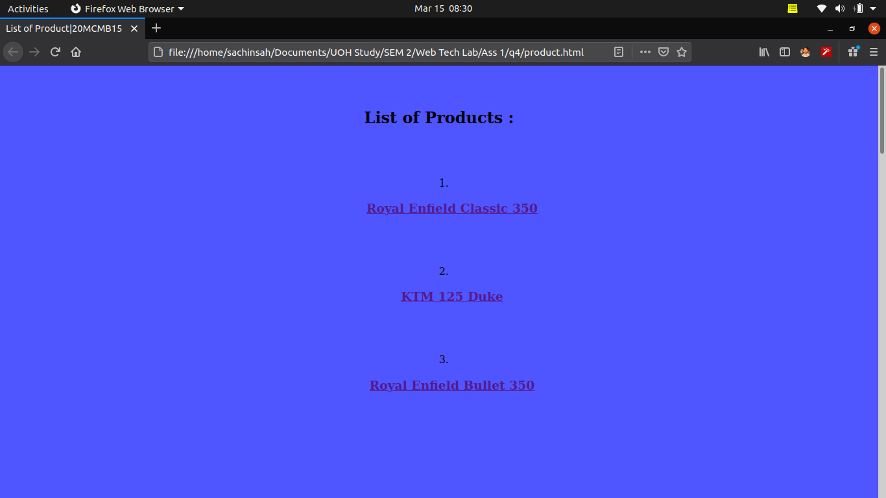
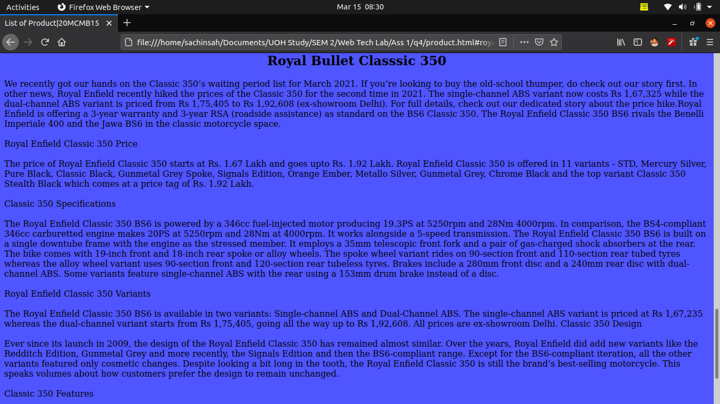
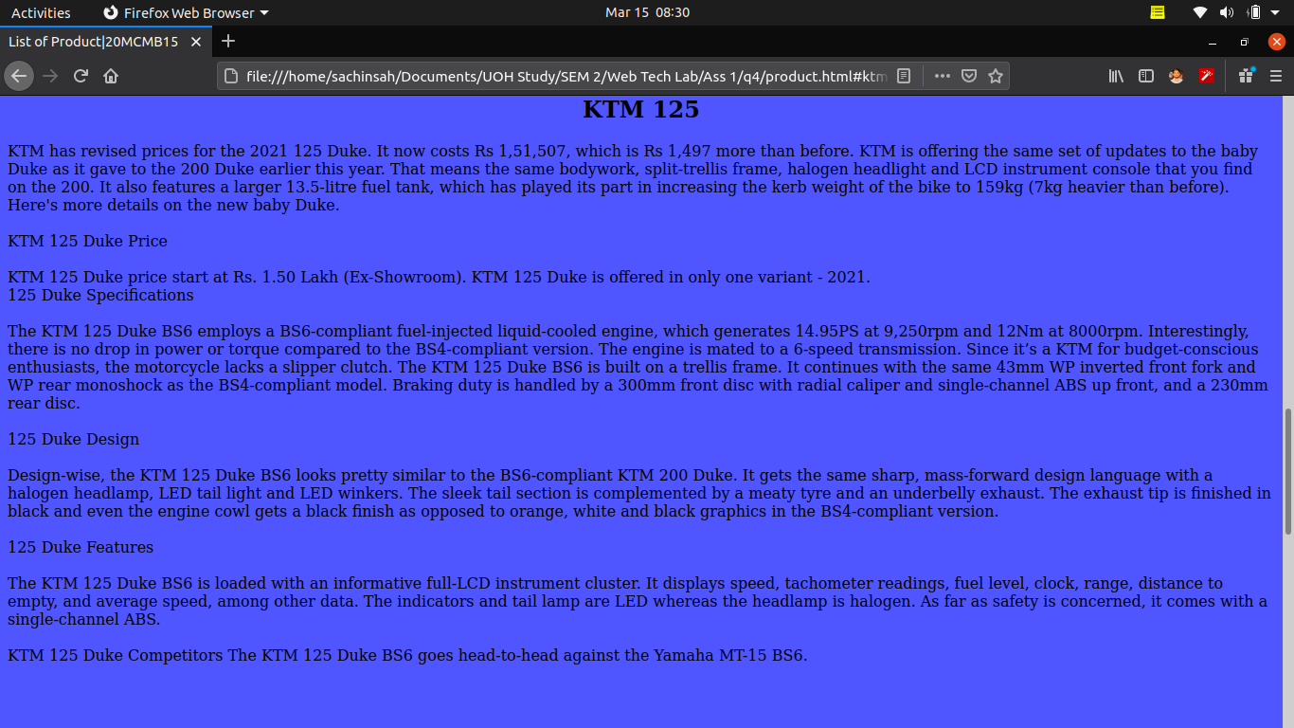
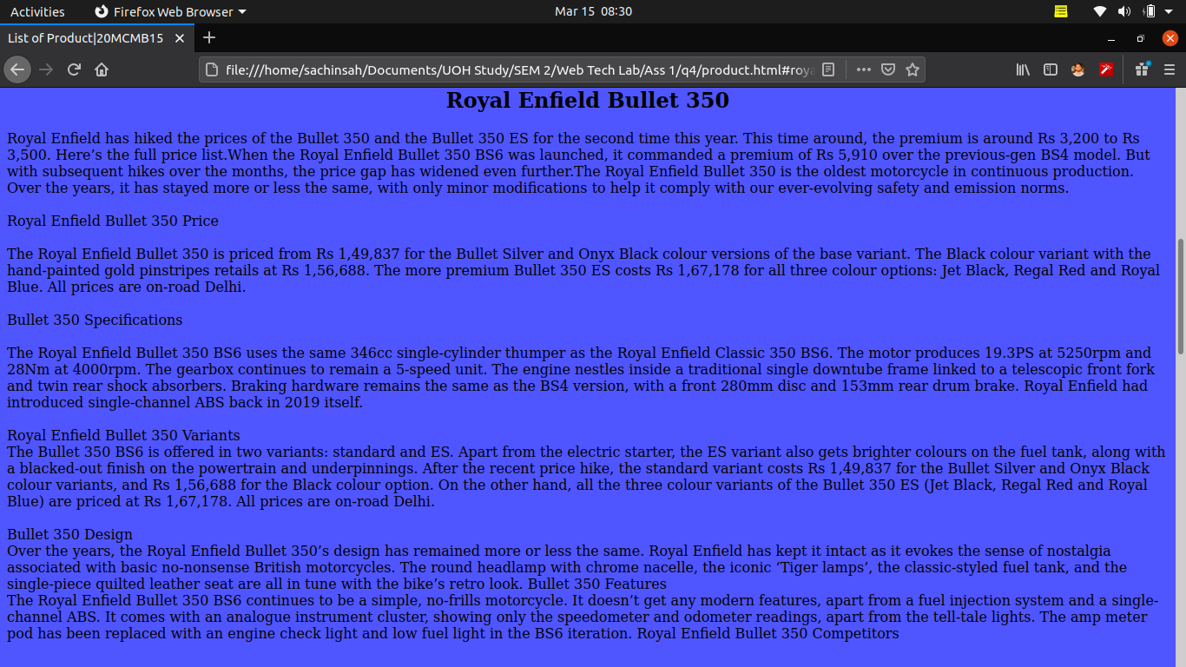

Q.5)

textformat.html

<!DOCTYPE html>
<html>
<head>
<title>Text Formatting | 20MCMB15</title>

<!-- css used for em tag to remove italic font with comes default and add underline font to it-->
<style type="text/css">
em{
font-style: normal;
text-decoration: underline;
}
</style>
</head>
<body>

<h1>Subscript</h1>
<h4> The &lt;sub&gt; tag defines subscript text. Subscript text appears half a character below the normal line, and is sometimes rendered in a smaller font.</h4>
Example<br>
<br><sub>Firebase</sub> is a platform developed by Google for creating mobile and web applications. It was originally an independent company founded in <sub>2011</sub>. In <sub>2014</sub>, Google acquired the platform and it is now their flagship offering for app development.

<h1>Superscript</h1>
<h4> The &lt;sup&gt; tag defines superscript text. Superscript text appears half a character above the normal line, and is sometimes rendered in a smaller font. </h4>
Example<br>
<br><sup>Firebase</sup> is a platform developed by Google for creating mobile and web applications. It was originally an independent company founded in <sup>2011</sup>. In <sup>2014</sup>, Google acquired the platform and it is now their flagship offering for app development.

<h1>Strike Through</h1>
<h4> The &lt;strike &gt; tag was used in HTML 4 to define strikethrough text. In HTML5 we can use the &lt;del&gt; tag to define deleted text:</h4>
Example<br>
<br><strike>Firebase</strike> is a platform developed by Google for creating mobile and web applications. It was originally an independent company founded in <strike>2011</strike>. In <strike>2014</strike>, Google acquired the platform and it is now their flagship offering for app development.

<h1>Super bold</h1>
<h4> The &lt;strong&gt; tag is used to define text with strong importance. The content inside is typically displayed in bold.</h4>
Example<br>
<br><strong>Firebase</strong> is a platform developed by Google for creating mobile and web applications. It was originally an independent company founded in <strong>2011</strong>. In <strong>2014</strong>, Google acquired the platform and it is now their flagship offering for app development.

<h1>Underline (other than &lt;U&gt;&lt;/U&gt;)</h1>
<h4> The &lt;em&gt; tag represents stress emphasis of its contents. The &lt;em&gt; tag is used when you need to emphasize a particular word or phrase within a sentence.</h4>
Example<br>
<br><em>Firebase</em> is a platform developed by Google for creating mobile and web applications. It was originally an independent company founded in <em>2011</em>. In <em>2014</em>, Google acquired the platform and it is now their flagship offering for app development.

</body>
</html>

OUTPUT :

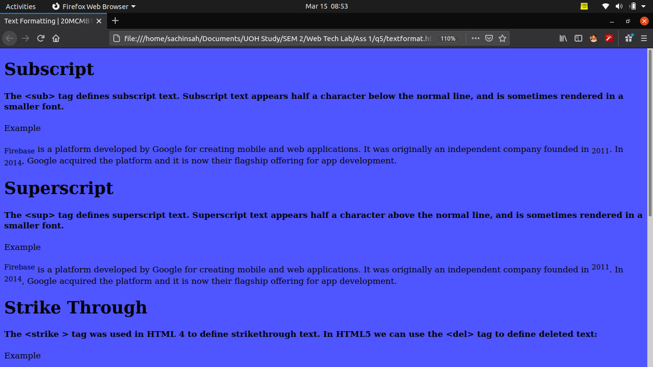
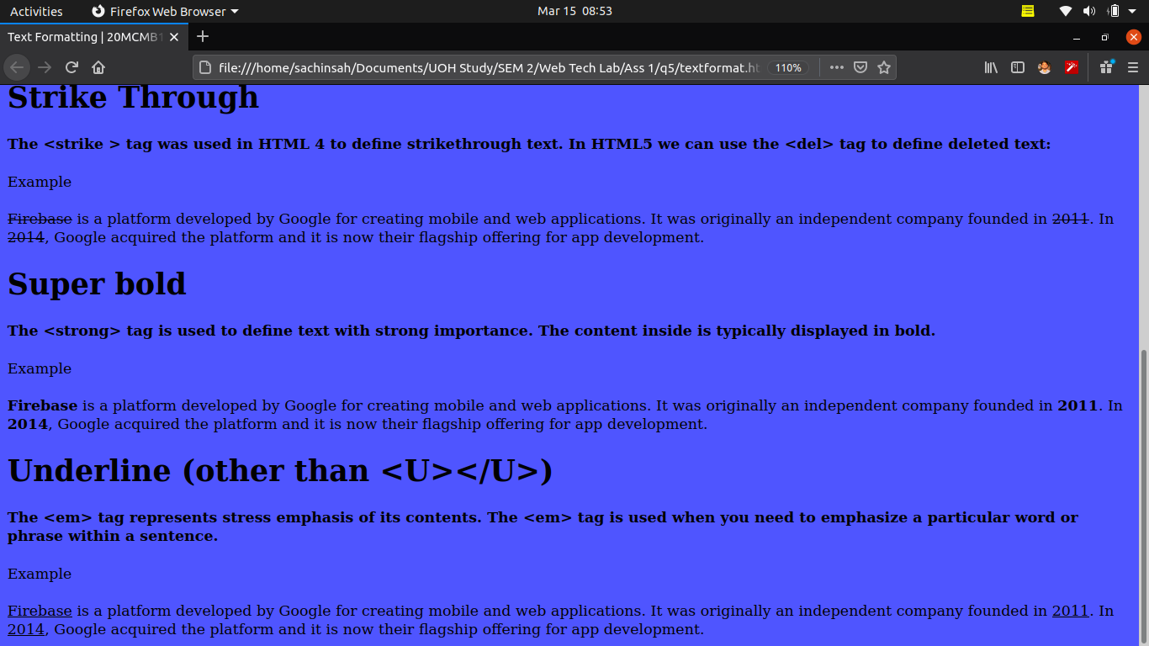

Q.6)

1.html

<!DOCTYPE html>
<html>
<head>
<title>Frame Format-1 | 20MCMB15</title>
<!-- This css is used to set body height to 100 so that iframe can acquire according to that-->
<link rel="stylesheet" type="text/css" href="../q1/index.css">
</head>
<body>
<!-- explained about iframe in Q.1-->
<iframe width="32%" height="10%"></iframe>
<iframe width="32%" height="10%"></iframe>
<iframe width="32%" height="10%"></iframe>
<iframe width="100%" height="90%"></iframe>

</body>
</html>

Output :

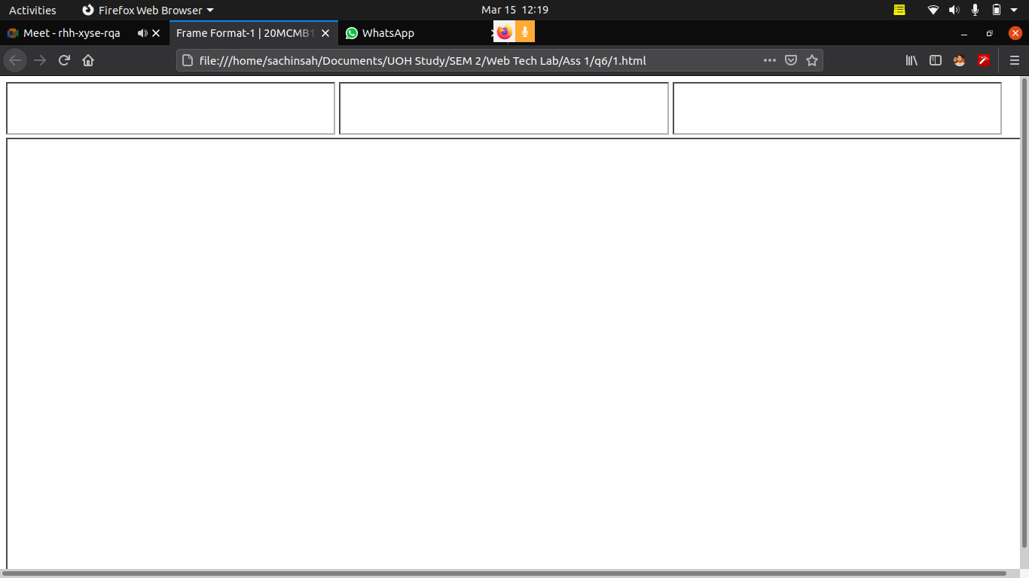
2.html

<html>
<head>
<title>Frame Format 2 | 20MCMB15</title>
</head>

<!-- The <frameset> tag is used to define the frameset and it contains one or more frame elements. It is used to specify the number of row and column in frameset with their pixel of spaces. Each element can hold a separate document -->
<frameset cols="50%,50%">
<frameset rows="33%,33%,34%">s
<frame src=" "><!-- The <frame> tag is used to define one particular window within a frameset. -->
<frame src=" ">
<frameset cols="50%,50%">
<frame src=" ">
<frame src=" ">
</frameset>
</frameset>
<frameset rows="33%, *">
<frame src=" ">
<frame src=" ">
</frameset>

</frameset>
</html>

OUTPUT :

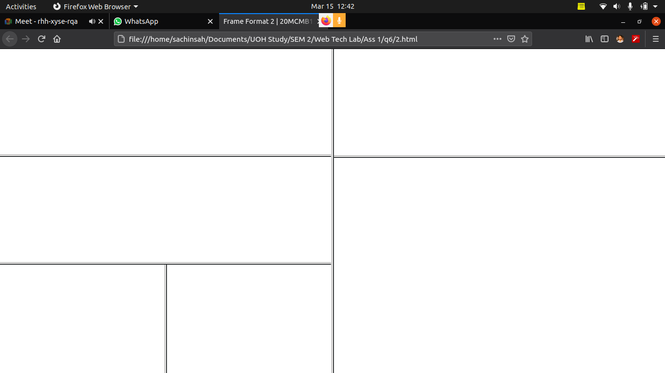
3.html

<html>
<head>
</head>
<frameset rows="33%, *">
<frame src=" ">
<frameset cols="25%,25%,25%,25%">

<frameset rows="50%, 50%">
<frame src=" ">
<frame src=" ">
</frameset>
<frameset rows="50%, 50%">
<frame src=" ">
<frame src=" ">
</frameset>
<frameset rows="50%, 50%">
<frame src=" ">
<frame src=" ">
</frameset>
<frame src=" ">
</frameset>
</frameset>
</html>

OUTPUT :

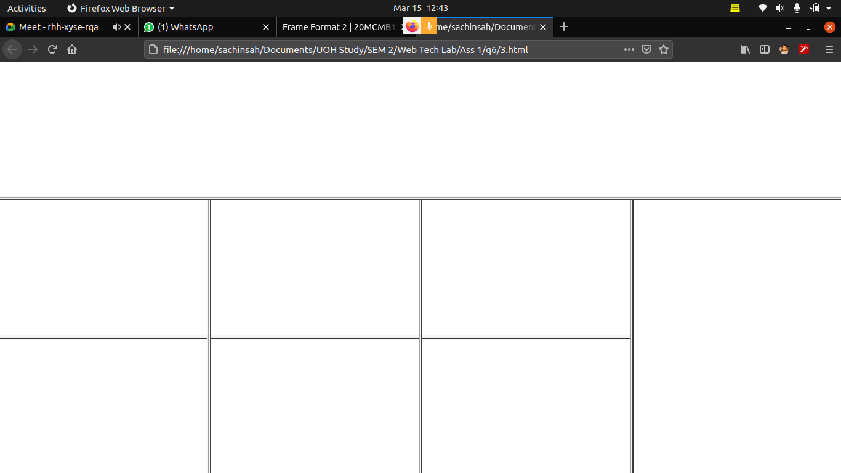
4.html

<html>
<head>
</head>
<frameset cols="50%, 50%">
<frame src=" ">
<frameset rows="25%,25%,25%,25%">
<frame src=" ">
<frame src=" ">
<frame src=" ">
<frame src=" ">
</frameset>

</frameset>
</html>

OUTPUT :

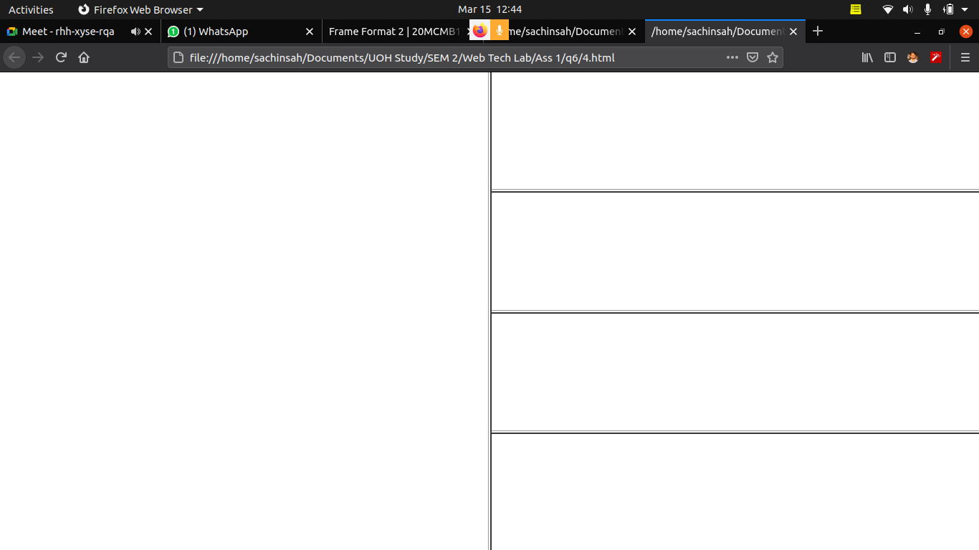
5.html

<html>
<head>
</head>
<frameset rows="33%,67%">

<frameset cols="20%,40%,20%,20%">
<frame src=" ">
<frame src=" ">
<frame src=" ">
<frame src=" ">
</frameset>

<frameset cols="20%,40%,40%">
<frame src=" ">
<frameset rows="50%,50%">

<frameset cols="50%,50%">
<frame src=" ">
<frame src=" ">
</frameset>

<frameset cols="50%,50%">
<frame src=" ">
<frame src=" ">
</frameset>

<frameset>

<frame src=" ">
</frameset>

</frameset>
</html>

OUTPUT :

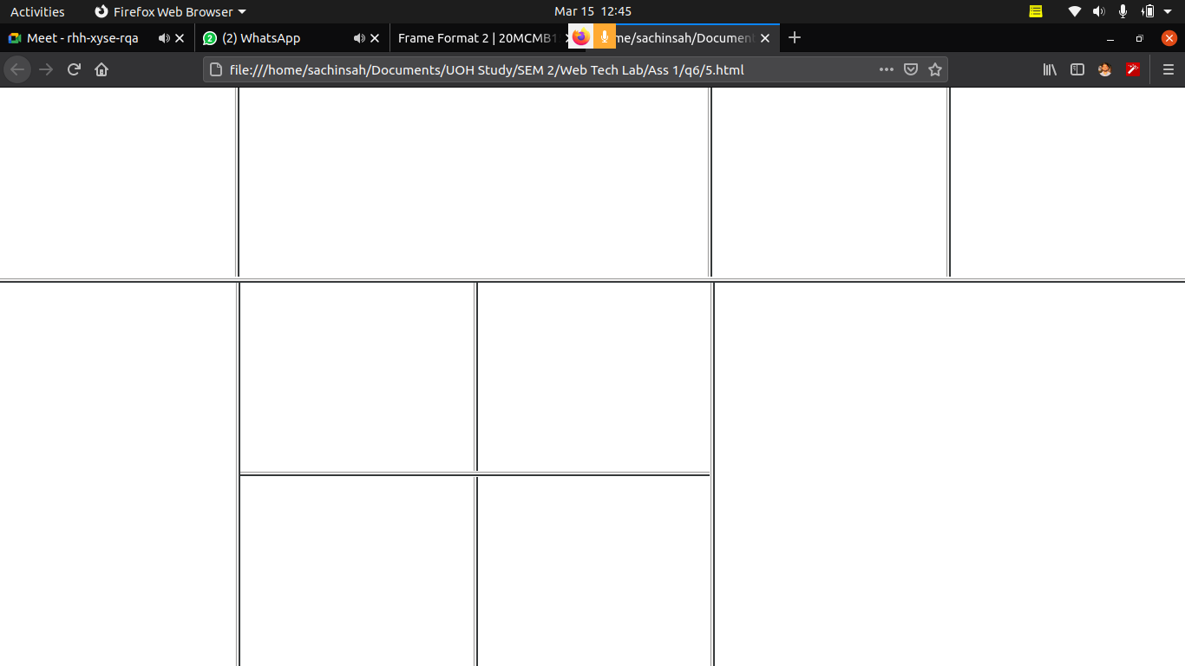

Q.7)

symbol.html

<!DOCTYPE html>
<html>
<head>
<title>Print Character | 20MCMB15</title>
<!-- for setting text in center of the field-->
<style type="text/css">

td{
text-align : center;
}
</style>
</head>
<body>

<label><center><h1>Print Other Characters</h1></label>
<table border="10" cellspacing="5" > <!-- cellscaping attribute for spacing between fields -->
<tr>
<td>SYMBOL
<td>DESCRIPTION
</tr>

<tr>
<td>&quot;
<td>Quotation Mark
</tr>

<tr>
<td>&amp;
<td>Ampersand Sign
</tr>

<tr>
<td>&lt;
<td>Less Than Sign
</tr>

<tr>
<td>&gt;
<td>Greater Than Sign
</tr>

<tr>
<td>&#169;
<td>copyright Symbol
</tr>

<tr>
<td>&#174;
<td>Registered Symbol
</tr>

<tr>
<td>&nbsp;
<td>Non breaking one space
</tr>

</table>
</center>

</body>
</html>

OUTPUT :

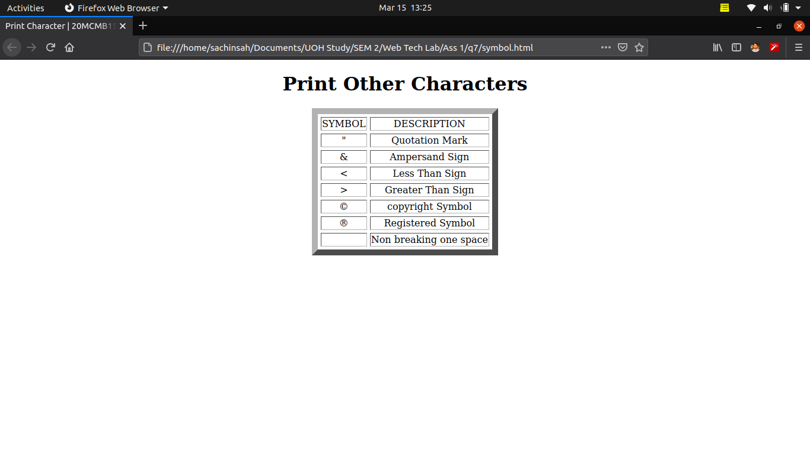

tags.html

<!DOCTYPE html>
<html>
<head>
<title>SELECT | TEXTAREA | 20MCMB15</title>
</head>
<body>

<center><!-- keep thing in the center of the screen -->
<h2>Select Coding Languages :</h2>
<select name="languages" > <!-- This <select> tag is used to create a drop-down list and for mutiple attribute to enable the multiple selection -->
<!-- option tag with add element in the drop-down list-->
<option value="java">JAVA</option> <br><br> <!-- value attribute is used for getting the value when corresponding option is selected -->
<option value="python" selected="true" >PYTHON</option> <br><br><!-- selection attribute set true will select the option by default -->
<option value="c">C</option> <br><br>
<option value="c++">C++</option> <br><br>
<option value="javascript">JAVASCRIPT</option> <br><br>
<option value="node.js">NODE.JS</option> <br><br>
</select>

<select id="codelang" name="languages" multiple="true" > <!-- This <select> tag is used to create a drop-down list , id & name attribute to track at other place means name for form data and id for associate with other and for mutiple attribute to enable the multiple selection -->
<!-- option tag with add element in the drop-down list-->
<option value="java">JAVA</option> <br><br> <!-- value attribute is used for getting the value when corresponding option is selected -->
<option value="python" selected="true" >PYTHON</option> <br><br><!-- selection attribute set true will select the option by default -->
<option value="c" selected="true">C</option> <br><br>
<option value="c++">C++</option> <br><br>
<option value="javascript">JAVASCRIPT</option> <br><br>
<option value="node.js" selected="true">NODE.JS</option> <br><br>
</select>

<br><br><br>
<!-- label is used for user to be more friendly usage-->
<label for="reviewaboutlang">Review on selected coding language</label><br>
<!-- The <textarea> tag defines a multi-line text input control and mostly used in a form, to collect user inputs like comments or reviews.-->
<!-- The size of a text area is specified by the <cols> and <rows> attributes.
The name attribute is needed to reference the form data after the form is submitted
The id attribute is needed to associate the text area with a label. -->
<textarea id="reviewaboutlang" name="reviewaboutlang" rows="4" cols="50">
Write your review here....
</textarea>

</center>

</body>
</html>

OUTPUT :

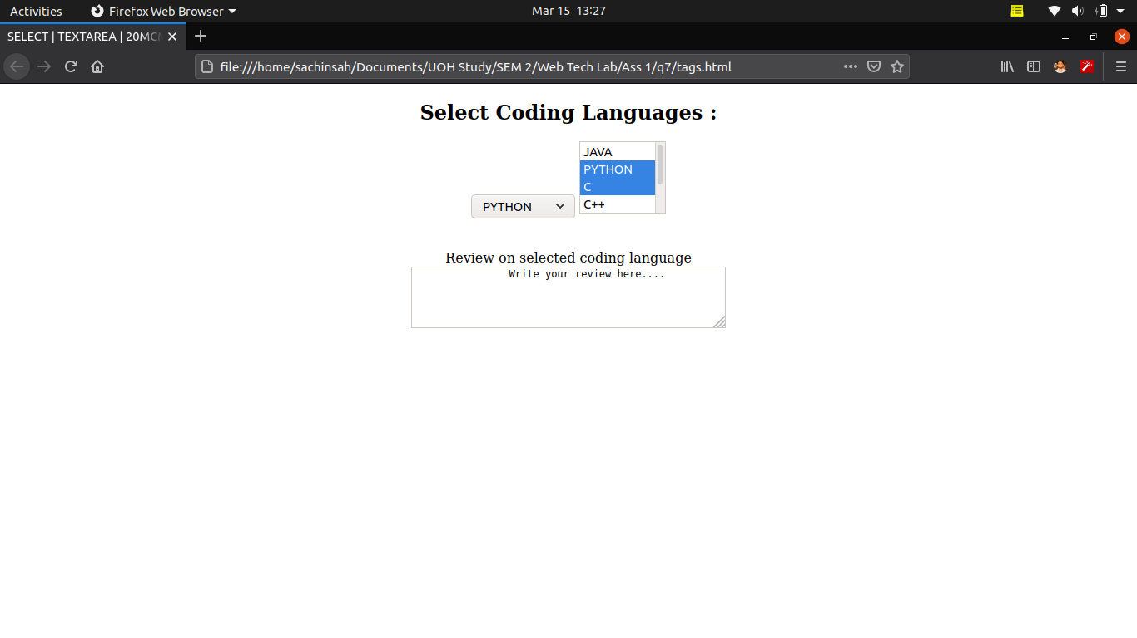

Q.8)

college.html

<!DOCTYPE html>
<html>
<head>
<title>UoH | 20MCMB15</title>
<link rel="stylesheet" type="text/css" href="../q1/index.css">
</head>
<body bgcolor="#4f55d2">

<iframe src="uoh_logo.png" width="13%" frameborder="1" scrolling="no"></iframe>
<iframe width="86%" src="collegetitle.html"></iframe>
<iframe name="main_frame" width="100%" height="72%"></iframe>
<iframe src="listques.html" width="100%" height="5%"></iframe>

</body>
</html>

collegetitle.html

<!DOCTYPE html>
<html>
<head>
<title></title>
,<center><h1>University of Hyderabad</h1></center>
</head>
</html>

listques.html

<!DOCTYPE html>
<html>
<head>
<title>List of Questions</title>
</head>
<body >

<a href="../q1/index.html" target="main_frame">Q.1</a>
<a href="../q2/timetable.html" target="main_frame">Q.2</a>
<a href="../q3/countries.html" target="main_frame">Q.3</a>
<a href="../q4/product.html" target="main_frame">Q.4</a>
<a href="../q5/textformat.html" target="main_frame">Q.5</a>
<a href="../q7/tags.html" target="main_frame">Q.7(a)</a>
<a href="../q7/symbol.html" target="main_frame">Q.7(b)</a>
</body>
</html>

OUTPUT :

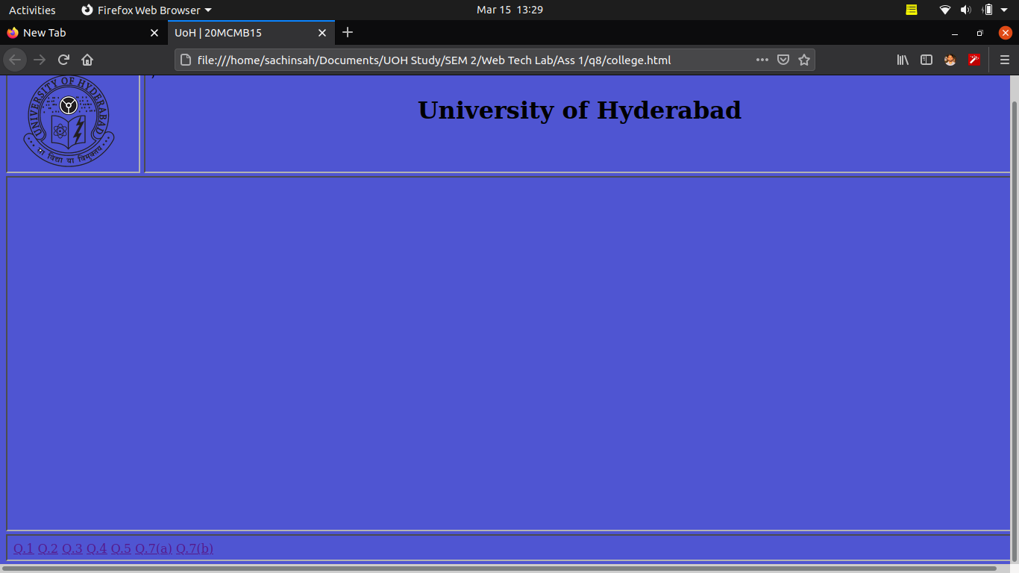
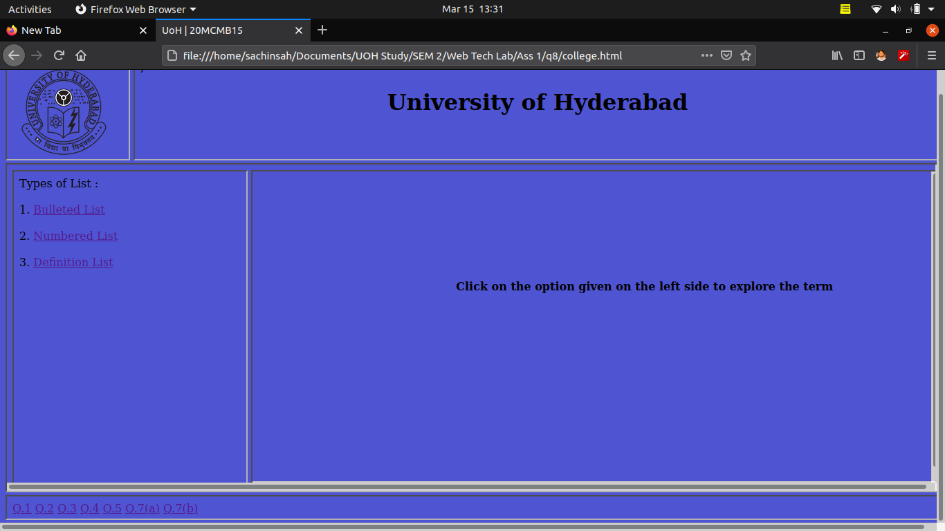
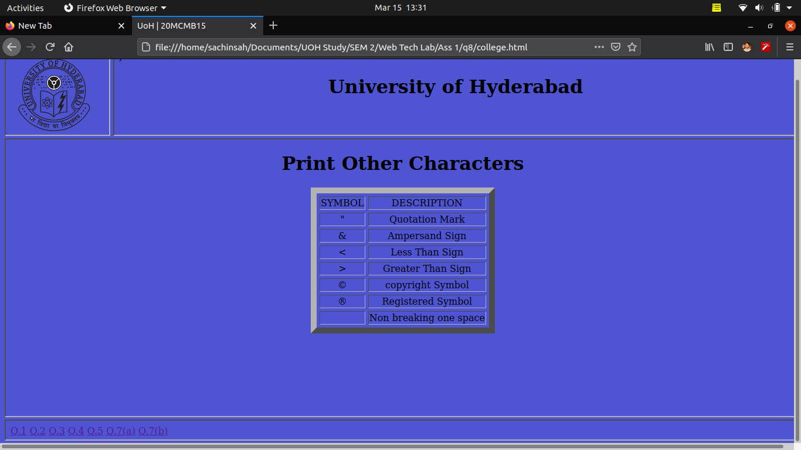

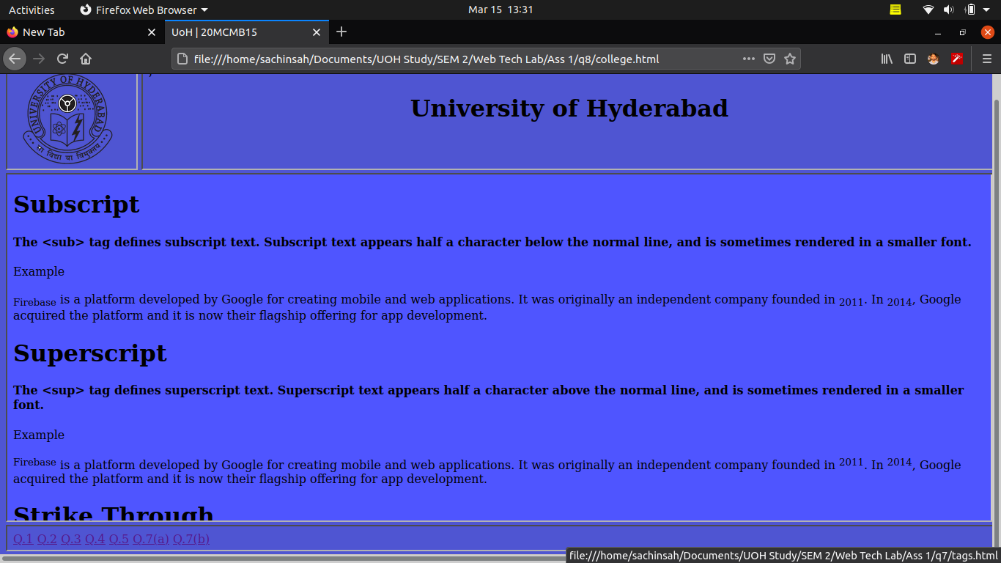

b.html

<!DOCTYPE html>
<html>

<head>
<title>Table | Paragrapg | 20MCMB15</title>
<link rel="stylesheet" href="style.css">
<style>
body {
font-family: Arial, Helvetica, sans-serif;
font-size: 20px;
text-align: justify;
}

.container {
margin-top: 70px;
margin-left: 100px;
margin-right: 100px;
}

h1 {
font-family: Arial, Helvetica, sans-serif;
font-weight: 100;
font-size: 35px;
text-align: center;
color: rgb(61, 61, 61);
}

#paragraph1 {
font-family: sans-serif;
font-style: italic;
padding: 50px;
}

#paragraph2 {
text-indent: 60px;
font-size: 23px;
line-height: 1.5;
}
</style>
</head>

<body bgcolor="#4f55d2">

<div class="container">

<!-- Table with styles for the table cells -->
<div id="tablecontainer">
<h1>Table</h1>
<table>
<!-- Heading row -->
<tr>
<th>Column 1</th>
<th>Column 2</th>
<th>Column 3</th>
<th>Column 4</th>
</tr>
<!-- row 1 -->
<tr>
<td class="red">Cell 11</td>
<td class="white">Cell 12</td>
<td class="red">Cell 13</td>
<td class="white">Cell 14</td>
</tr>
<!-- row 2 -->
<tr>
<td class="red">Cell 11</td>
<td class="white">Cell 12</td>
<td class="red">Cell 13</td>
<td class="white">Cell 14</td>
</tr>
<!-- row 3 -->
<tr>
<td class="red">Cell 11</td>
<td class="white">Cell 12</td>
<td class="red">Cell 13</td>
<td class="white">Cell 14</td>
</tr>
</table>
</div>

<!-- Paragraph 1 with style-->
<div>
<h1>Paragraph 1</h1>
<p id="paragraph1">
Paragraphs can contain many different kinds of information. A paragraph could contain a series of brief examples or a single long illustration of a general point. It might describe a place, character, or process; narrate a series of events; compare or contrast two or more things; classify items into categories; or describe causes and effects. Regardless of the kind of information they contain, all paragraphs share certain characteristics. One of the most important of these is a topic sentence.
</p>
</div>

<!-- Paragraph 2 with different style-->
<div>
<h1>Paragraph 2</h1>
<p id="paragraph2">
Compose and send an e-mail message from the Wildcats Mail system that
satisfies the following requirements:
Include two addresses in the To: field of this message (separated by a semicolon):
the course submission address (abc@xyz.com) and your own e-mail address.
In the Subject: field enter the text Assign #1 followed by your first and last name.
In the body of your message:
introduce yourself and let me know by what name you prefer to be addressed;
briefly describe what, if any, experience you have with computers and/or
networking; and tell me why you decided to take this course.
The body of your message must consist of at least three paragraphs of at least
three sentences each.
</p>
</div>

</div>

</body>

</html>

style.css

/* Style for table */

table{
width: 1200px;
margin: auto;
table-layout: fixed;
text-align: center;
margin-top: 50px;
margin-bottom: 100px;
font-family: Arial, Helvetica, sans-serif;
}

table, th, td{
border: 1px dotted rgb(0, 0, 179);
border-collapse: collapse;
padding: 10px;
font-size: 23px;
}

th{
background-color: silver;
}

/* cell background */

.red{
background-color: lightcoral;
}

.white{
background-color: white;
}

OUTPUT :

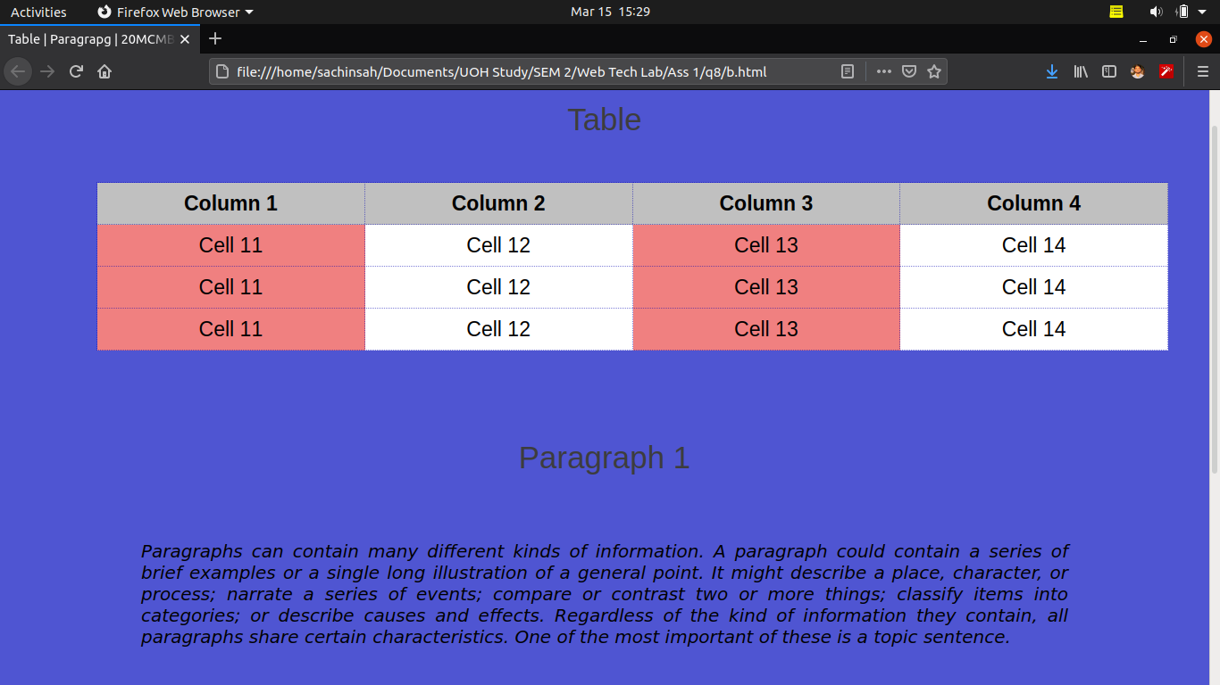

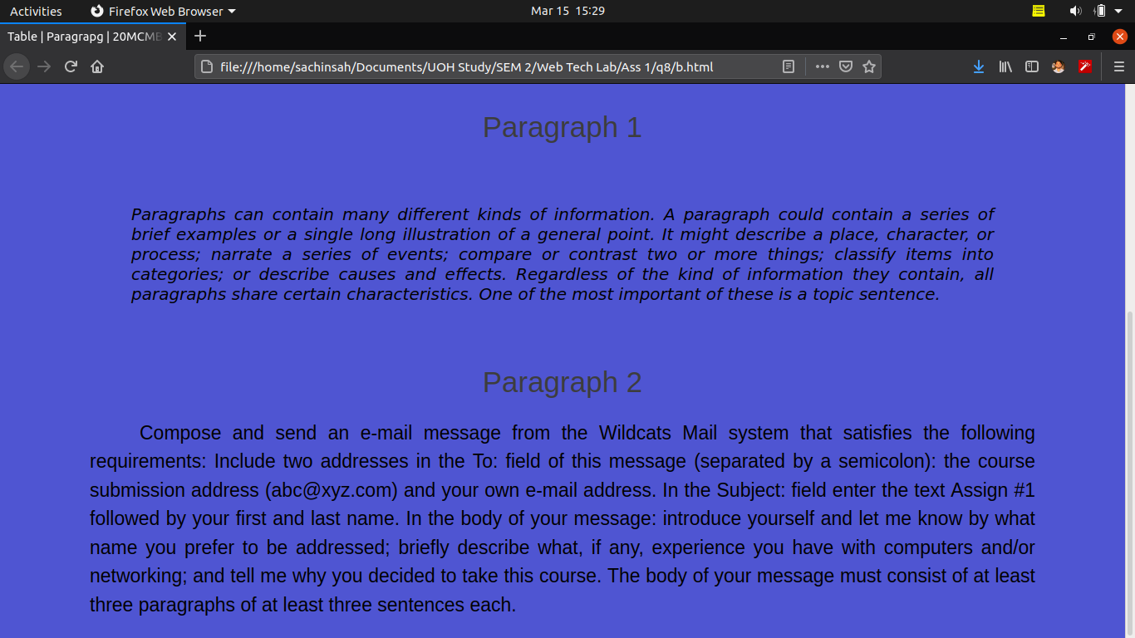

Q.9)

a.html

<!DOCTYPE html>
<html>
<head>
<title>Profile | 20MCMB15</title>
<link rel="stylesheet" type="text/css" href="../q1/index.css">
</head>
<body>

<iframe src="name.html" width="100%"></iframe>
<iframe src="menu.html" width="20%" height="68%"></iframe>
<iframe name="main_frame" width="59%" height="68%"></iframe>
<iframe src="" width="18%" height="68%"></iframe>

<center> Contact : 7802008521 Email : ssk1222014@gmail.com </center>

</body>
</html>

menu.html

<!DOCTYPE html>
<html>
<head>
<title>Menu | 20MCMB15</title>
<style type="text/css">

a:link{
color: green;
}

a:visited{
color: blue;
}

a:active{
color: red;
}
</style>
</head>
<body>

<a href="desc.html#objective" target="main_frame"> Objective </a><br><br><br>
<a href="desc.html#pinfo" target="main_frame"> Personal Information </a><br><br><br>
<a href="desc.html#finfo" target="main_frame"> Family Information </a><br><br><br>
<a href="desc.html#eduinfo" target="main_frame"> Educational Information </a><br><br><br>
<a href="desc.html#experience" target="main_frame"> Experience </a><br><br><br>
<a href="desc.html#achievements" target="main_frame"> Achievements </a><br><br><br>
<a href="desc.html#other" target="main_frame"> Others </a>

</body>
</html>

name.html

<!DOCTYPE html>
<html>
<head>
<title>Name | 20MCMB15</title>
</head>
<body>

<center>
<h1>Sachin Sah</h1>
<br><h4> Pursuing Mtech(IT) | Former System Engineer | Java Developer</h4>
</center>

</body>
</html>

desc.html

<!DOCTYPE html>
<html>
<head>
<title>Description</title>
<style type="text/css">
section{
height: 100vh;
}
</style>
</head>
<body>

<label ></label>
<section id="objective">
<br><br><center> <h1>Objective</h1> </center>
To work in a firm with a professional work in driven environment where I can utilize and apply my knowledge, skills which would enable me to grow while fulfilling organizational goals.
</section>

<section id="pinfo">
<br><br><center> <h1>Personal Information</h1> </center>
I am Sachin Sah and am from surat, Gujarat. I have done diploma in computer engineering after 10th from R.C. Technical Institute, Ahmedabad. I have completed by BE in Computer Science from Maharaja Sayajirao university of baroda. I am currently pursuing Mtech in Information Technology from University of Hyderabad.
</section>

<section id="finfo">
<br><br><center> <h1>Family Information</h1> </center>
My father is supervisor in mechanical company and my mom is a housewife.
</section>

<section id="eduinfo">
<br><center> <h1>Educational Information</h1> </center><br><br>
Master of Technology (Information technology)<br>
University of Hyderabad<br>
Hyderabad, India<br>
<br>
Bachelor of Engineering (Computer Science)<br>
Maharaja Sayajirao University<br>
Vadodara, India<br>
<br>
Diploma in Computer Engineering<br>
Gujarat Technical University<br>
Ahmedabad, India<br>
<br>
High School<br>
Gujarat Secondary And Higher Secondary<br>
Education Board<br>
Surat, India<br>

</section>

<section id="experience">
<br><br><center> <h1>Experience</h1> </center><br><br>
System Engineer<br>
Axelor Technologies India Pvt. Ltd.<br>
05/2019 - 03/2020,<br>
Surat, India<br><br>
Achievements/Tasks<br>
Worked on Axelor Open Suite (ERP) application and also
client projects based on ERP software modifications.<br>
Expanded Knowledge in Java | Hibernate | PostgreSQL |
RestAPI | Guice | Gradle | Git.
</section>

<section id="achievements">
<br><br><center> <h1>Achievements</h1> </center><br><br>
- Represented college in cricket<br>
- Executive member of the Event Organizing
Committee in Diploma College.
</section>

<section id="other">
<br><br><center> <h1>Other</h1> </center><br><br>
LANGUAGES KNOWN<br>
English<br>
Professional Working Proficiency
Hindi<br>
Full Professional Proficiency<br>
Gujarati<br>
Full Professional Proficiency<br>
Bihari<br>
Full Professional Proficiency<br>

<br><br>
HOBBIES<br>
bodybuilding<br>
playing a musical instruments<br>
Playing Games<br>
Cooking
</section>

</body>
</html>

OUTPUT :

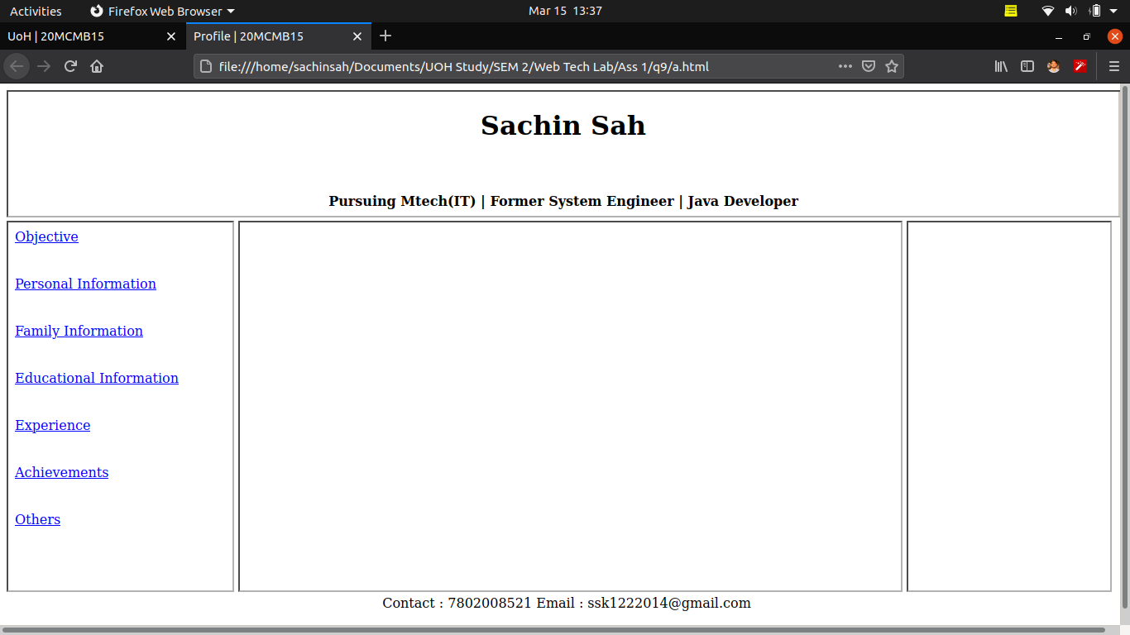
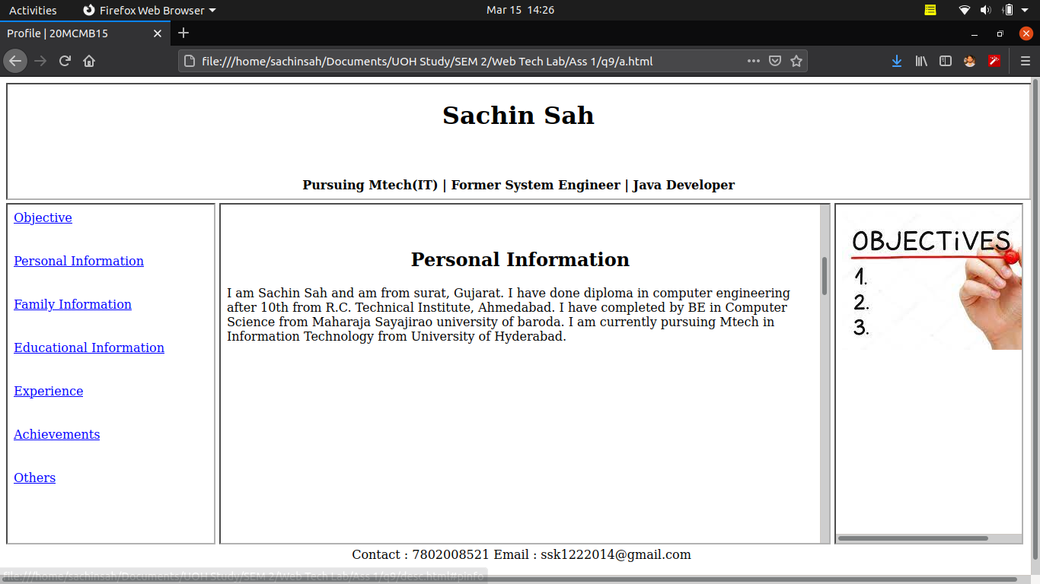

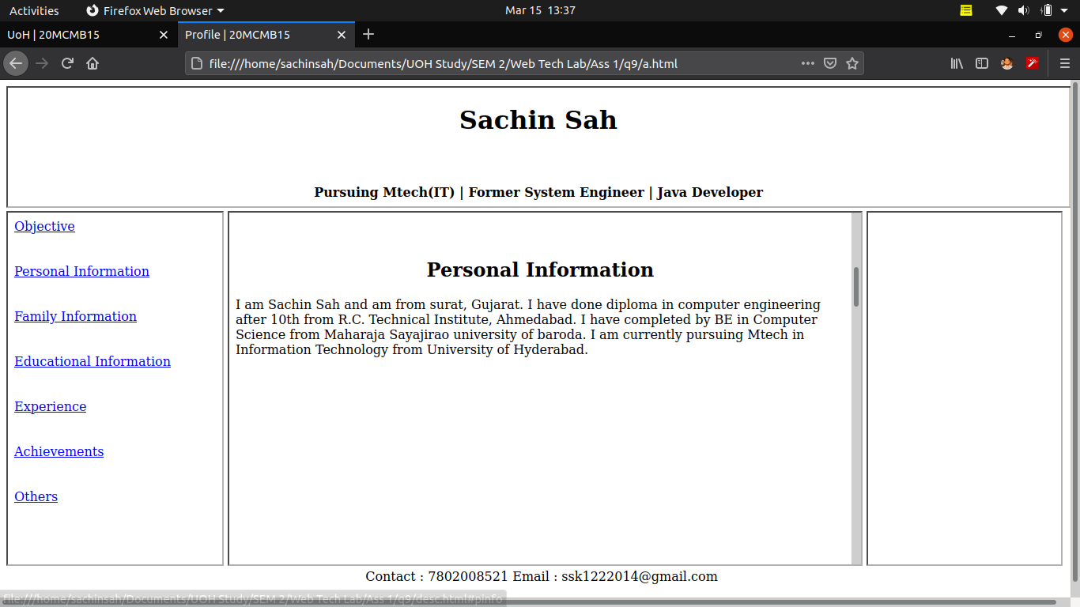
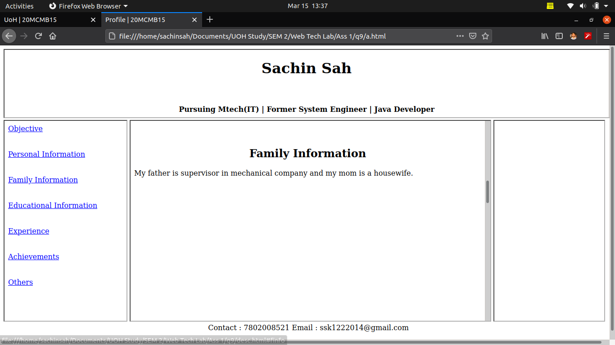
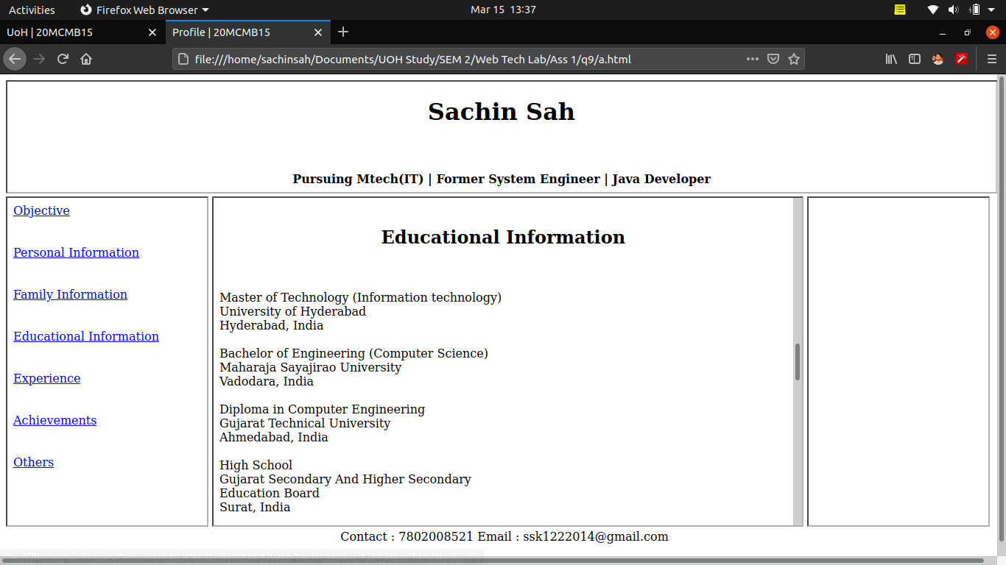
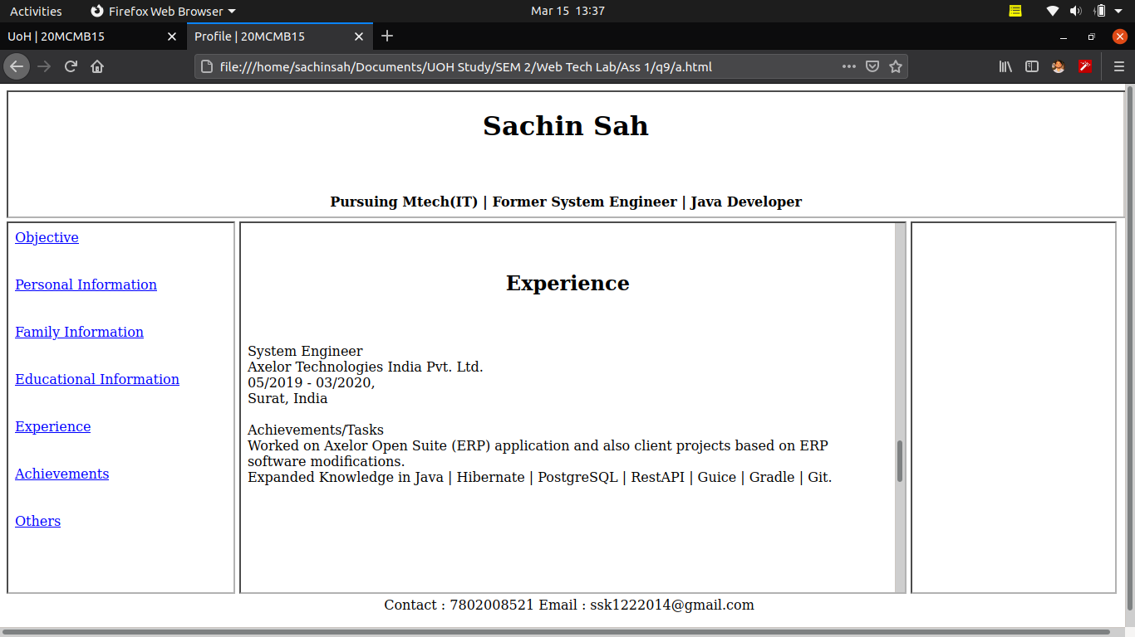

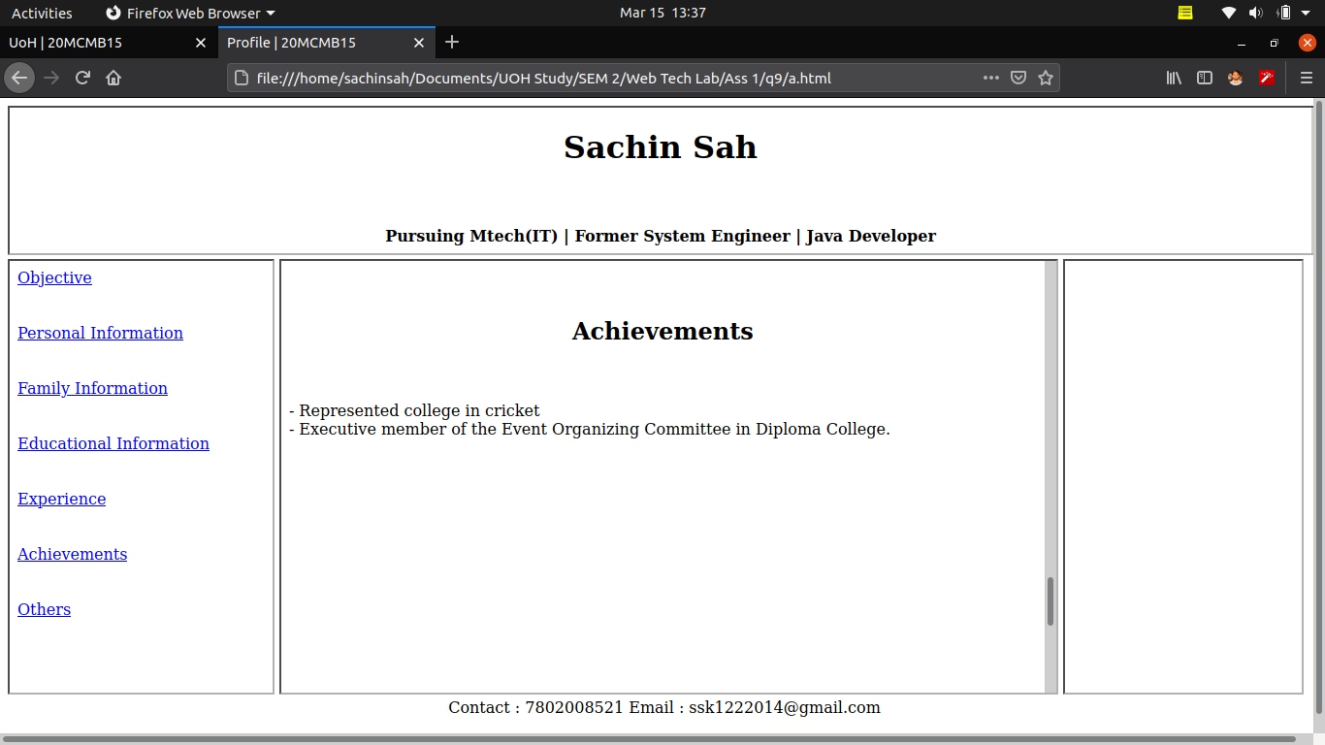
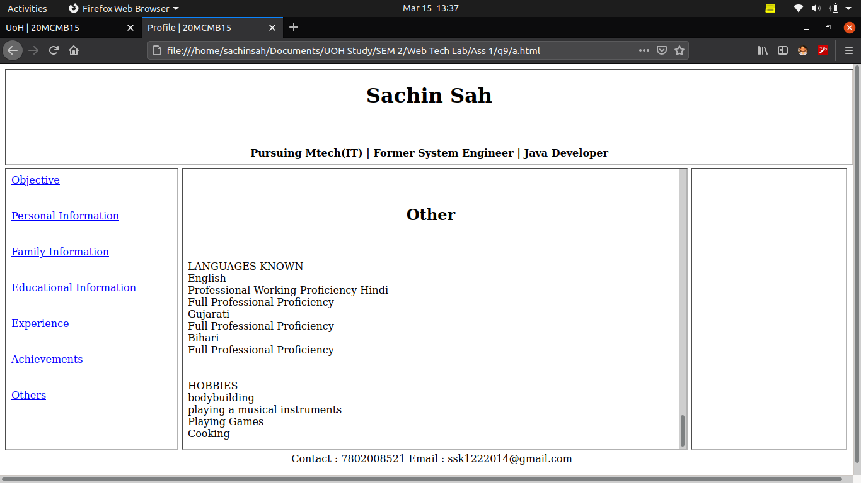

b.html

<!DOCTYPE html>
<html>
<head>
<title>Different types of Link | 20MCMB15 </title>
</head>
<body>

<center><br><br>
<ol>
<li> <a href="a.html"> Linking web pages internally </a>
<li> <a href="../q1/index.html"> Linking web pages externally </a>
<li> <a href="https://uohyd.ac.in"> <img src="../q8/uoh_logo.png" width="100" height="100"> </a>
<li> <a href="https://uohyd.ac.in" href="https://www.egov.uohyd.ac.in/login"> <img src="weblogo.jpg" alt="Web Logos" usemap="#logos" /> </a>
</ol>

<map name="logos">
<area shape="circle" coords="68,56,33" href="http://www.stumbleupon.com/" title="StumbleUpon" alt="StumbleUpon" />
<area shape="rect" coords="220,19,306,54" href="http://www.youtube.com/" title="Youtube" alt="Youtube" />
<area shape="rect" coords="367,32,516,84" href="http://www.google.com/" title="Google" alt="Google" />
<area shape="rect" coords="556,12,639,115" href="http://www.wikipedia.com/" title="Wikipedia" alt="Wikipedia" />
<area shape="rect" coords="128,62,244,114" href="http://www.skype.com/" title="Skype" alt="Skype" />
<area shape="rect" coords="301,103,444,136" href="http://www.yahoo.com/" title="Yahoo" alt="Yahoo" />
<area shape="rect" coords="25,158,135,207" href="http://www.ebay.com/" title="eBay" alt="eBay" />
<area shape="rect" coords="180,147,271,175" href="http://www.flickr.com/" title="Flickr" alt="Flickr" />
<area shape="rect" coords="299,166,379,208" href="http://www.digg.com/" title="Digg" alt="Digg" />
<area shape="circle" coords="500,184,32" href="http://wordpress.org/" title="Wordpress.org" alt="Wordpress.org" />
<area shape="rect" coords="599,142,667,209" href="http://www.blogger.com/" title="Blogger" alt="Blogger" />
<area shape="default" nohref="nohref" title="Default" alt="Default"/>
</map>
</center>
</body>
</html>

OUTPUT :

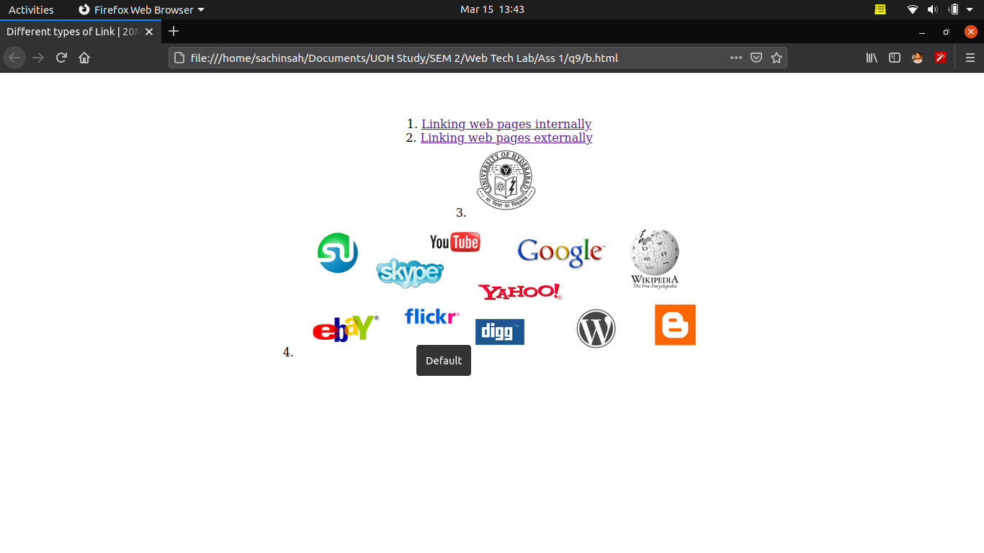

Q.10)

a.html

<!DOCTYPE html>
<html>
<head>
<title>Online Registration</title>
<center><h1>Online Registration of the International Seminar</h1></center>
</head>
<body bgcolor="#4f55d2">

<form method="POST">

Participant Type :
<select name="subject">
<option disabled="disabled" selected="selected">Choose option</option>
<option>Student</option>
<option>Faculty</option>
<option>Professionals</option>
<option>Company/firm</option>
</select>
<br><br>
<label>First Name</label>
<input type="text" name="first_name"><br><br>

<label>Last Name</label>
<input type="text" name="last_name"><br><br>

Company/College <input type="text" name="company"><br><br>
Email <input type="email" name="email"><br><br>
Area Code <input type="text" name="area_code"><br><br>

<label></label>Phone Number</label>
<input type="text" name="phone"><br><br>

Registration Fees : <input type="text" name="fees">
<select name="currency">
<option disabled="disabled" selected="selected">Choose option</option>
<option>Rs.</option>
<option>$</option>
</select>
<br><br>

Payment Mode :
<select name="Payment">
<option disabled="disabled" selected="selected">Choose option</option>
<option>Credit Card</option>
<option>Debit Card</option>
<option>Demand Draft</option>
</select>
<br><br>

<label >Accept all the constraint and all the data entered is correct?
</label>
<label>Yes
<input type="radio" checked="checked" name="exist">
</label>
<label>No
<input type="radio" name="exist">
</label><br><br>
<button type="submit">Register</button>
</form>
</body>
</html>

OUTPUT :
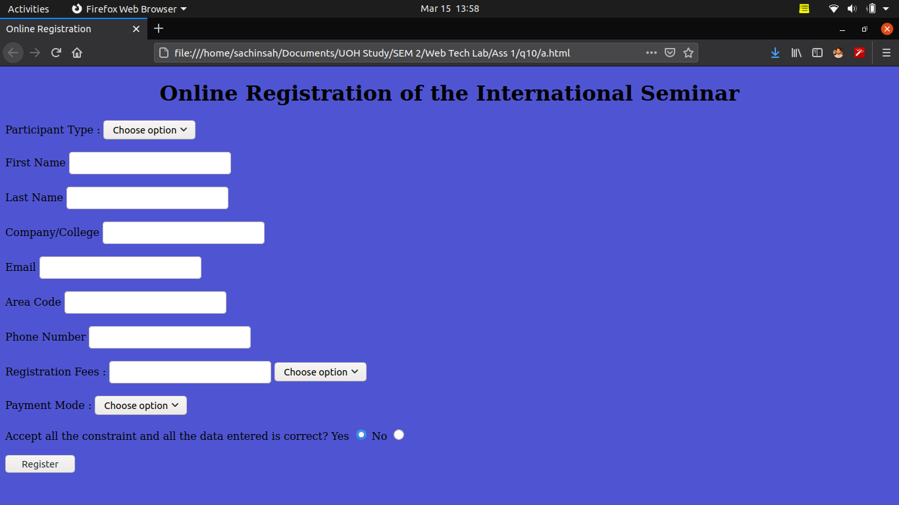

b.html

<!DOCTYPE html>
<html lang="en">

<head>

<title>Email Message | 20MCMB15</title>

<!-- Style -->

<style>
#composer {
padding-left: 10px;
padding-right: 10px;
}

#heading {
font-size: 20px;
color: white;
padding-left: 10px;
padding-top: 8px;
padding-bottom: 8px;
background-color: black;
border-top-left-radius: 10px;
border-top-right-radius: 10px;
}

#to {
font-size: 20px;
padding-left: 10px;
padding-top: 5px;
}

#to input {
font-size: 20px;
width: 97%;
border: none;
padding: 5px;
}

#subject {
font-size: 20px;
padding-left: 10px;
}

#subject input {
font-size: 20px;
width: 97%;
border: none;
padding: 5px;
}

textarea {
resize: none;
border: none;
width: 800px;
height: 470px;
padding: 10px;
margin: 5px;
font-size: 20px;
}

#send {
font-size: 20px;
background-color: rgb(63, 92, 255);
color: white;
padding: 5px;
border-radius: 5px;
width: 100px;
}

#btn {
text-align: right;
margin-right: 10px;
margin-bottom: 5px;
}
</style>
</head>

<body bgcolor="#4f55d2">
<!-- Heading -->
<div id="heading">
Compose
</div>

<!-- compose section -->
<div id="composer">

<!-- reciever email address -->
<div id="to">
<input type="email" placeholder="To">
</div>
<hr>

<!-- email subject -->
<div id="subject">
<input type="text" placeholder="Subject">
</div>
<hr>

<!-- Body of the Email-->
<div id="message">
<textarea name="message" placeholder="Message"></textarea>
</div>

<input type="submit" value="Send" id="send">
</div>
</body>

</html>

OUTPUT :

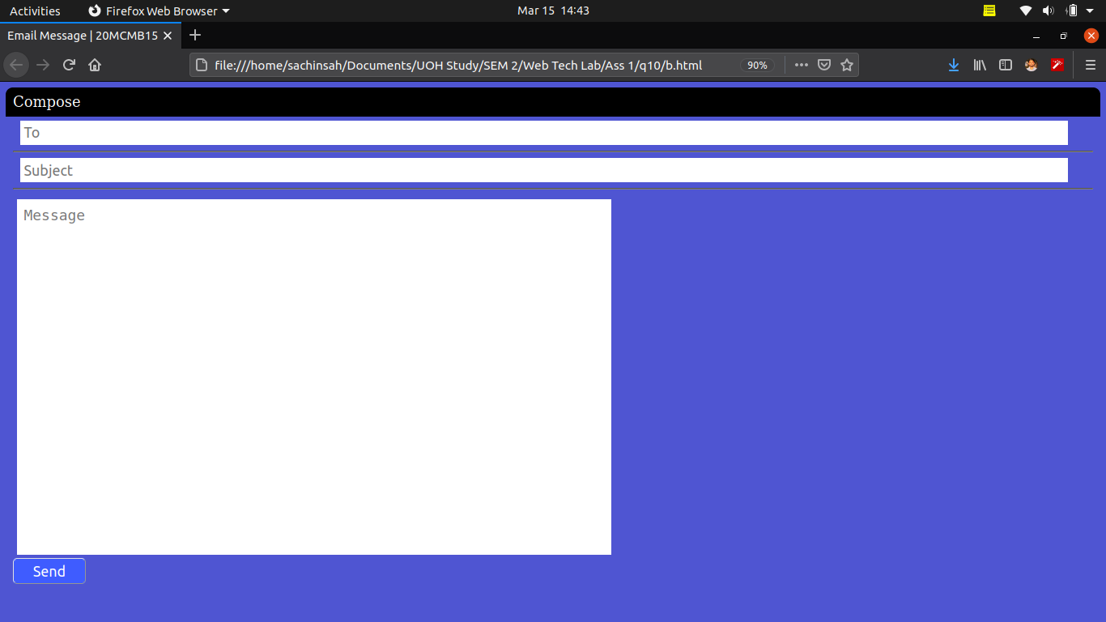

References :

https://www.javatpoint.com/
https://www.geeksforgeeks.org
https://www.tutorialspoint.com/index.htm
https://www.studytonight.com/code/html/
https://www.w3schools.com/
https://stackoverflow.com/

